13.2 PDCS OS PLUS Windows

Windows are organized by subsystem and by functional group within subsystem listed to match the menu sequence in OS PLUS, reading from left to right and top down. For each window, the documentation provides a Window Specification that describes what the window does, how the navigation works, and any custom features. This is followed by the Window Layout (a screen capture from the test system with any personal identification masked), and a Window Exhibit with field-by-field specifications. The electronic documents for the Windows section are stored as separate documents for ease of maintenance.
- Part 1 includes:
  - General overview of OS PLUS window functionality
  - Customer/Group/ Plan subsystem windows
- Part 2 includes the Provider subsystem windows.
- Part 3 includes the Participant subsystem windows.
- Part 4, sections 1 and 2 include the Claims subsystem windows. Claims Section 1 includes the following Functional Groups:
  - Batch Control
  - Batch Release
  - Exam Entry
  - Adjustment
  - Mass Adjustment
Claims Section 2 includes the following Functional Groups:
  - Credit
  - Inquiry
  - Suspense Correction
  - Suspense Release
  - History Adjustment
- Part 5, sections 1, 2 and 3 include the Reference subsystem windows. Reference Section 1 includes the following Functional Groups:
  - Diagnosis
  - Drug
Reference Section 2 includes the following Functional Groups:
  - Claim Exception Codes
  - Therapeutic Groups
  - Drug Program
  - Step Care
  - Inferred Disease
  - DUR
Reference Section 3 includes the following Functional Groups:
  - Text
  - System
  - TPL Carrier
  - Parameter Reports
  - Error Report
- Part 6 includes the window documentation for these subsystems:
  - Switch Vendor
  - Prior Authorization/Prior Authorization Maintenance
13.2.1 Windows Overview

PDCS OS PLUS utilizes a Java-based graphical user interface (GUI) on the front-end for enhanced navigation and is supported by relational database architecture. The web-enabled GUI windows provide a user-friendly interface to a system that accommodates a wide variety of claim processing requirements through the setting of system parameters and database tables.

This section begins with a discussion of general windows functionality for PDCS OS PLUS. Following this discussion is a bulleted list of the PDCS OS PLUS windows according to menu selection entries. All the identified windows are then documented using three forms:

- Window Specification
- Window Layout
- Window Exhibit

Note that the valid value numbers in the Specifications column of the Window Exhibit tables can be found in System Documentation Section 13.6, PDCS OS PLUS Database Valid Values.

13.2.1.1 General Window Functionality

Unless otherwise specified below, the PDCS OS PLUS subsystems referenced in this section correspond to the horizontal menu bar buttons at the top of the PDCS OS PLUS windows. Functional Groups refer to submenu options in drop-down lists under certain main menu options. Within subsystems and functional groups, information is organized based on tab windows. Once a user has performed a search to return data within a subsystem or functional group, additional details can be obtained by simply clicking on the tabs to move throughout available windows within that subsystem or functional group.

Records Table

A record (also referred to as a row) appears in a records table as a line item. A records table displays the records that:

- Meet specific search criteria, or
- Contain related information from the database for the Pane title.

Click an underlined table header to sort the records alpha/numerically by that column.

A record link (usually the value in the first column):

- Opens a page displaying the record’s details or
- Displays the record’s details in fields below the records table, and
- Makes available any relevant buttons for that record, i.e., Update, Delete, etc.

The total number of records displayed in the records table is shown at the bottom left of the table.

Address Types

Each address record is associated with an “Address Type”. The “Address Type” codes are consistent throughout the system (e.g. for Participant, Provider, etc.). A drop-down list displays the description of each “Address Type” code, including Billing, Correspondence, Mailing, Physical, Remittance, etc . .

Wildcard Searches

Some PDCS OS PLUS search pages allow wildcard searches when, for example, a user is unsure of the correct spelling of an entire name, or wishes to save keystrokes. Some searches require a minimum of three characters to use the “%” key as a wildcard. Other pages do not require a character minimum to use the %. Those search pages allow a “% only” search to return all results for the “Search by” criteria. The type of search allowed for each search page is designated in the Window Specification. The wildcard is not required to search for exact “Search for” criteria.

- Use % at the end of a partial entry to return results that begin with the exact characters to the left of the %.
- Use % at the beginning of a partial entry to return results that end with the exact characters to the right of the %.
- Use % anywhere within the partial entry to return results with the exact characters to the left of the % and to the right of the %.
- Note: If the % is used anywhere in the entry other than at the end, a % must also be placed at the end of the entry.

Date Fields

All date fields are displayed in the 8-digit mm/dd/yyyy format unless noted. The default “beginning of time” date is 01/01/0001. The default “end of time” date is 12/31/9999. A record is considered active if the “Begin Date” is before today and the “End Date” is after today.

Searches

“Search for” entries are not case sensitive. Some search pages open with results displayed; others require a search to return records based on the selected search criteria. Generally, if there is only one record that meets the search criteria, the first page of information for that record opens. Returning to a search page from anywhere in the application displays the results of the last search on that page. If a search returns a message indicating there are more records than those displayed, make the primary search more specific or refine the search using additional search criteria fields. Users can use the primary and secondary search fields together to perform a search. The spinning Windows® icon at the top right of the Internet browser window tells users the system is “working” to process an action.

Messages

A message box appears when the database is searching for records. This message box closes when the operation is complete. Other message types display at the top of a page with information pertaining to an action just taken, such as when a search returns more than 500 records and the search criteria should be refined to return fewer records . .A third type of message box generally appears when a user needs to confirm an action (such as deleting a record) or make a decision.

Update Information

View update information (user ID, date, and time) for a record or for pane information:

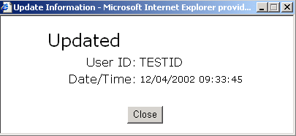

To open the Update Information message box,

- Click the U link found at the end of the row for every record in a records table.
- Click the Show Last Update link found in the upper right hand corner of a pane.

A blank “User ID” usually indicates the system made the last update.

Drop-Down Lists

Generally, when a drop-down list uses a vertical scroll bar, press the first letter of the value to display the options list. Then, the first value in the list beginning with that letter is highlighted.

Access Rights

Access levels can be specified down to the field level per user. For example, administrative users have the ability to add, save, update, and delete records and data based on their personal access. If some functions described in this document are not available to a user or are hidden, that user does not have administrative access to those functions (buttons, fields, links, etc.).

13.2.1.2 Window Documentation

The following PDCS OS PLUS tab windows are documented here::

Log On

PDCS OS PLUS Log On (Portal Entry)

Customer/Group/Plan Subsystem

Customer Functional Group
Search
Customer
Address
Pricing
Group Functional Group
Search
Group
Network
Plans
Plan Functional Group
Search
Plan
Detail
Copay
Limits
Custom Record Detail

Provider Subsystem

Physician Functional Group
Search
Provider
Physician
License/Specialty
Review/CrossRef.
Misc.
Affiliations
Notes
Pharmacy Functional Group
Search
Pharmacy
Network/Alt ID/EFT
Notes
Review/Audit
Affiliations

Participant Subsystem

Search
Member
Address
Plan Coverage
Lock-in
COB
Alternate ID
Other Info
Benefit Limits
Injury
Seniors
Eligibility Programs

Claims Subsystem

Batch Control Functional Group
Search
Batch Control Detail
Batch Release Functional Group
Locked Batches Information
Exam Entry Functional Group
Search
Doc List
Claim
Line Items
Misc Fields
Misc Tables
History
Adjustment Functional Group
Search
Adjustment Information
Documents
Claim Adjustment
Line Items
Misc Fields
Misc Tables
History
Mass Adjustment Functional Group
Mass Adjustment/Void
Mass Adjustment Preview
Credit Functional Group
Search
Credit Information
Inquiry Functional Group
Search
Claim
Line Items
Misc Fields
Misc Tables
History
Suspense Correction Functional Group
Search
Doc List
Claim
Line Items
Misc Fields
Misc Tables
Suspense Release Functional Group
Search
Release
History Adjustment Search Functional Group
Selection

CI (this PDCS OS PLUS menu option is actually a shortcut to the Claims Inquiry Search window)

Reference Subsystem

Diagnosis Functional Group
Search
Diagnosis
Drug Functional Group
Search
Drug
Classification
Pricing
Formulary
Indications/Contraindications
Precautions
Coverage
Rebate StatusClaim Exception Codes Functional Group
Search
Claim Exception
Claim Disposition
Claim Disposition (Auto-Generate)
Exception Override by County
Therapeutic Groups Functional Group
Therapeutic Group
Add Therapeutic Group
Edit Therapeutic Group
Drug Program Functional Group
Search
Program
Detail Select
Detail
NDC
Step Care Functional Group
Search
Step Care
Agents
Inferred Disease Functional Group
Search
Inferred Disease
DUR Functional Group
Search
DUR
Text Functional Group
Location
Search
Text
RA EOB
Search
Text
PA Reason
Search
Text

System Functional Group
Range Numbers
Batch Control
System Lists
Search
Header
Detail
System Parameters
Search
Header
Detail
Module Control
Module Control
Customer Hierarchy
Customer Hierarchy
Customer Group XRef
Customer Group Cross Reference
TPL-Carrier Functional Group
Search
Carrier
Parameter Reports Functional Group
Search
Report
Error Report Functional Group
Error Log Information
Transaction Functional Group
Transaction Search
Transaction View

Switch Vendor Subsystem

Summary
Detail

PA Subsystem

Search (PA Information)
Search (Intervention Information)
PA
Intervention

PA Maintenance (this PDCS OS PLUS menu button actually takes the user to the maintenance windows for the PDCS OS PLUS PA subsystem)

Problem
Program
Problem/Program

13.2.2 Log On Window

The Log On window allows the user to access the PDCS OS PLUS system and perform various administrative functions including password change.

New Mexico PDCS OS PLUS Log On
Window Specification
Log On

Window Name:
Log On
Description:
The Log On window allows authorized users to access data within the PDCS OS PLUS system.
Window Type:
Response window
Navigation:
The user accesses the Log On window by entering the web portal address into a web browser . .If the user’s ID and password are correct and he or she has current access to the system, the Customer Search window opens . .If the user enters an invalid ID or password, or he or she does not have current access to the system, a Logon Failure window opens.
Interface to Other Subsystem(s):
N/A
Interface to Other Application(s):
N/A
Special Security Requirements:
Access to PDCS OS PLUS is restricted to authorized users . .A user’s access rights within the system are determined at logon based on security credentials maintained by PDCS OS PLUS administrators.
Presentation Sequence(s):
N/A
Remarks:
The PDCS OS PLUS Log On portal window allows the user to perform several administrative tasks . .As the following Window Layout shows, the Log On window also allows users to request a forgotten password, and request system access (note that this feature is currently under development) . .

Once a user logs in to PDCS OS PLUS, the portal screen remains open in the background as a second web browser window . .Returning to this window allows the user to change his or her PDCS OS PLUS password, or log out of PDCS OS PLUS (note that the user can also log out by closing both PDCS OS PLUS browser windows).

New Mexico PDCS OS PLUS Log On
Window Specification
Log On

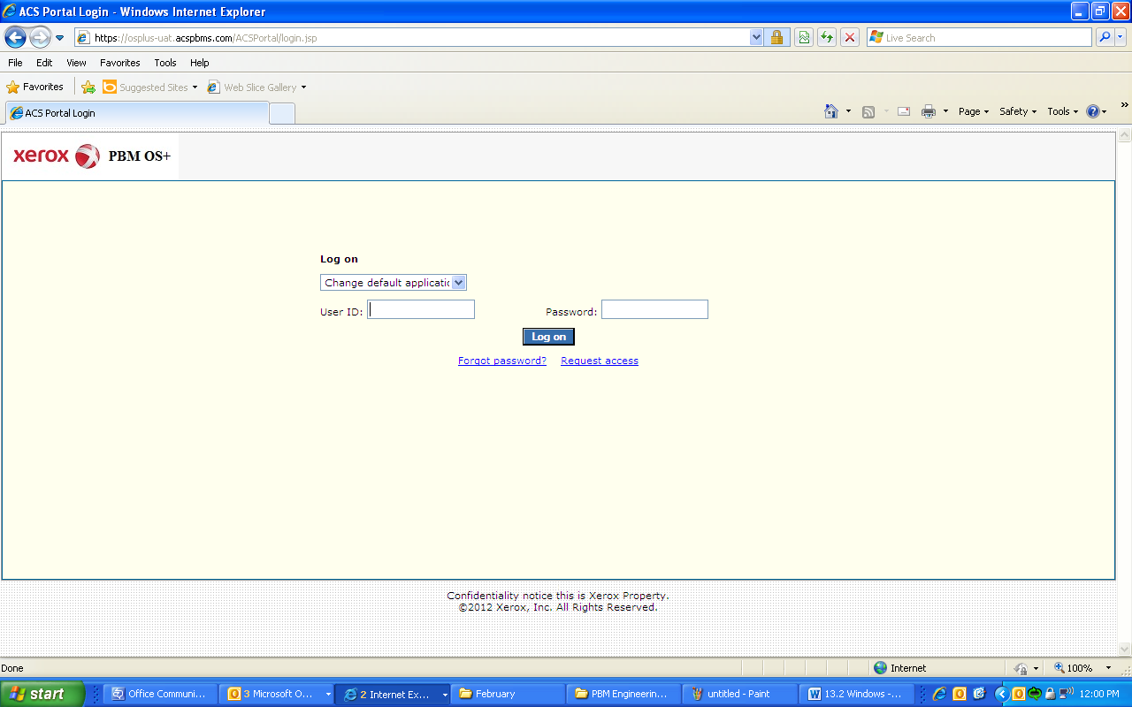

New Mexico PDCS OS PLUS Log On
Window Specification
Log On
Field Name | Table Column Name | Table Name | Format | Prot. (A,C,N) | Req.  (A,C,N) | Std. Edits | Specifications | Note  Ref.
Change Default Application? | DEFAULT_APP | SEC_USERS_T | Drop-down List | C | C | N/A | This lets the user retain the current default application in their browser.
User ID | USER_ID | SEC_USERS_T | X(10) | A | A | N/A
Password | PASSWORD | SEC_USERS_T | X(10) | A | A | N/A
Command Buttons | Group | N/A | Free Form | N/A | N/A | N/A | Grouping
Log on | N/A | N/A | Push Button | A | A | N/A | Required to access the OS PLUS application
Forgot Password? | N/A | N/A | Link | N | N | N/A | This takes the user to a screen so the application can send a new password.
Request Access | N/A | N/A | Link | N | N | N/A | Currently does not have any functionality

Legend
Prot. and Req. | Standard Edits | Note Ref.
A = Always | D = Date Edit | C = Customer-specific field or functionality
C = Conditionally | N = Numeric Edits | R = Note Reference
N = Never | S = System Generated
 | V = Valid Value Edit

Ref. No. | Notes
N/A | N/A

13.2.3 Customer/Group/Plan Windows

The Window section contains a list of the functional groups and a brief description of each.

- The Customer Functional Group contains windows that allow the user to add, update, and/or inquire on customer information.
- The Group Functional Group contains windows that allow the user to add, update, and/or inquire on group information.
- The Plan Functional Group contains windows that allow the user to add, update, and/or inquire on plan information.

Each of these is described in detail separately, beginning below.

13.2.3.1 Customer Functional Group

This functional group provides the user the ability to:

- Inquire on customer information
- Update customer information
- Add a new customer

The following tab windows are used by the Customer Functional Group:

- Search
- Customer
- Address
- Pricing

The following data is displayed in the title bar of all tab windows (i.e., not on search windows) in this functional group:

- Customer Name

New Mexico PDCS OS PLUS Customer/Group/Plan Subsystem
Window Specification
Customer Functional Group
Search Tab Page

Window Name:
Customer: Search
Description:
The Customer Search window is the first window that appears when a user logs into the system . .It is the single point of entry into the remainder of the PDCS OS PLUS subsystems in order to restrict customer data.
Window Type:
Response window
Navigation:
The user enters this window from the Log On window or by clicking the Customer option on the PDCS OS PLUS Customer/Group/Plan subsystem menu . .
Interface to Other Subsystem(s):
N/A
Interface to Other Application(s):
N/A
Special Security Requirements:
When accessing New Mexico Medicaid data via PDCSOS PLUS, New Mexico FA and customer staff can see only their two Customer options, NEWMEX and NMENCO . .One of these Customers must be selected in order to access data within the PDCSOS PLUS system.

Add Customer functionality is restricted to authorized users.
Presentation Sequence(s):
N/A
Remarks:
N/A

New Mexico PDCS OS PLUS Customer/Group/Plan Subsystem
Window Layout
Customer Functional Group
Search Tab Page

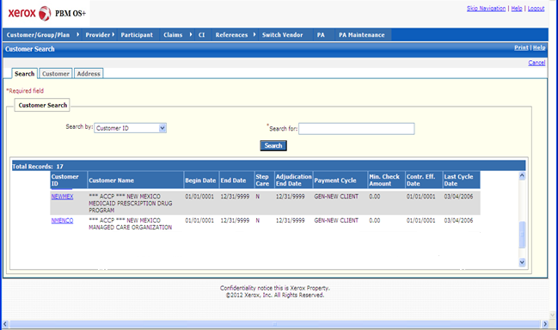

New Mexico PDCS OS PLUS Customer/Group/Plan Subsystem
Window Exhibit
Customer Functional Group
Search Tab Page
Field Name | Table Column Name | Table Name | Format | Prot. (A,C,N) | Req.  (A,C,N) | Std. Edits | Specifications | Note  Ref.
Customer Search Results Display | Group | N/A | Free Form | N/A | N/A | N/A | Grouping
Customer ID | R_CUST_ID | R_CUST_DTL_TB | X (06) | A | N | N/A
Customer Name | R_CUST_NAM | R_CUST_DTL_TB | X (60) | A | N | N/A
Begin Date | R_CUST_BEG_DT | R_CUST_DTL_TB | DATE | A | N | N/A
End Date | R_CUST_END_DT | R_CUST_DTL_TB | DATE | A | N | N/A
Step Care | R_STEP CARE_IND | R_CUST_DTL_TB | X (1) | A | N | N/A | Valid Values List 0077
Adjudication End Date | R_END_ADJUD_DT | R_CUST_DTL_TB | DATE | A | N | N/A | Must be a valid date
Payment Cycle | R_PYMT_CYCL_CD | R_CUST_DTL_TB | X (2) | A | N | N/A | Valid Values List 0042
Min. Check Amount | R_MIN_CHK_AMT | R_CUST_DTL_TB | 999,999,999.99 | A | N | N/A
Contr. Eff. Date | R_CNTRCT_EFF_DT | R_CUST_DTL_TB | DATE | A | N | N/A | Must be a valid date
Last Cycle Date | R_LAST_CYCL_DT | R_CUST_DTL_TB | DATE | A | N | N/A
Total Records | N/A | N/A | Display | A | N | N/A | Computed
Search Entry Group | Group | N/A | Free Form | N/A | N/A | N/A | Grouping
Search by | N/A | N/A | Drop-down | N | N | V | Search by defaults to Customer ID . .Customer Name is the other Search by option.  Valid Values List 7281
Search for | N/A | N/A | N/A | N | A | N/A | Required Field . .Wild card (%) search can be invoked using three or more characters followed by a wild card (%).
Search | N/A | N/A | Push Button | N | N | N/A

Legend
Prot. and Req. | Standard Edits | Note Ref.
A = Always | D = Date Edit | C = Customer-specific field or functionality
C = Conditionally | N = Numeric Edits | R = Note Reference
N = Never | S = System Generated
 | V = Valid Value Edit

Ref. No. | Notes
N/A | N/A

New Mexico PDCS OS PLUS Customer/Group/Plan Subsystem
Window Specification
Customer Functional Group
Customer Tab Page

Window Name:
Customer: Customer
Description:
The Customer window is the first window that appears when the customer is selected from the Customer Search window . .It contains customer and administrative fee information.

The Customer Information pane is used to record key customer information including history months to keep, payment cycle, and brand method . .
Window Type:
Response window
Navigation:
The user enters this window from the Customer Search window.
Interface to Other Subsystem(s):
N/A
Interface to Other Application(s):
N/A
Special Security Requirements:
Authority to add customers is required to access the Add Customer link . .Add, Update, and Delete functionality for Administrative Fee Information is restricted to authorized users.
Presentation Sequence(s):
N/A
Remarks:
N/A

New Mexico PDCS OS PLUS Customer/Group/Plan Subsystem
Window Layout
Customer Functional Group
Customer Tab Page

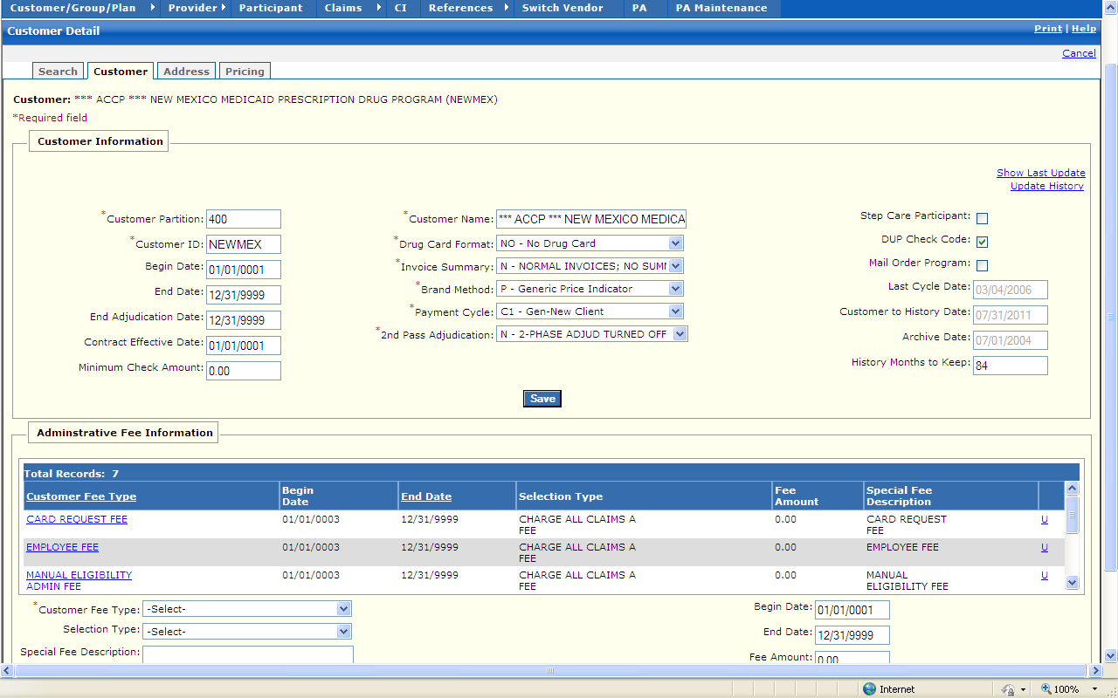

New Mexico PDCS OS PLUS Customer/Group/Plan Subsystem
Window Exhibit
Customer Functional Group
Customer Tab Page
Field Name | Table Column Name | Table Name | Format | Prot. (A,C,N) | Req.  (A,C,N) | Std. Edits | Specifications | Note  Ref.
Customer | R_CUST_NAM & R_CUST_ID | R_CUST_DTL_TB | Display | A | N | N/A | This field is populated based on the Customer ID chosen upon login.
Show Last Update | G_AUD_USER_ID, G_AUD_TS | G_LIST_DTL_TB | X (20), Time-Stamp | A | C | N/A | By selecting the Show Last Update Link, a pop-up window is displayed showing User ID, Date and Time of when the record was initially created, and when it was last updated.
Customer Information | Group | N/A | Free Form | N/A | N/A | N/A | Grouping
Customer Partition | R_CUST_PART_NUM | R_CUST_DTL_TB | 9,999 | A | A | V | Valid Values List 4329
Customer ID | R_CUST_ID | R_CUST_DTL_TB | X (6) | A | A | V | Valid Values List 7281 | R2
Begin Date | R_CUST_BEG_DT | R_CUST_DTL_TB | DATE | A | C | D | Must be a valid date. | R4
End Date | R_CUST_END_DT | R_CUST_DTL_TB | DATE | A | C | D | Must be a valid date. | R6
End Adjudication Date | R_END_ADJUD_DT | R_CUST_DTL_TB | DATE | A | C | D | Must be valid date
Contract Effective Date | R_CNTRCT_EFF_DT | R_CUST_DTL_TB | DATE | A | C | D | Must be valid date
Minimum Check Amount | R_MIN_CHK_AMT | R_CUST_DTL_TB | 999,999,999.99 | N | C | N |  | R8
Customer Name | R_CUST_NAM | R_CUST_DTL_TB | X (60) | N | A | N/A
Drug Card Format | R_DRUG_CARD_FMT  _CD | R_CUST_DTL_TB | Drop-down | N | N | V | Valid Values List 0028
Invoice Summary | R_ADMIN_SUM_CD | R_CUST_DTL_TB | Drop-down | N | A | V | Valid Values List 0075
Brand Method | R_BRND_MTHD_CD | R_CUST_DTL_TB | Drop-down | N | A | V | Valid Values List 0078
Payment Cycle | R_PYMT_CYCL_CD | R_CUST_DTL_TB | Drop-down | N | A | V | Valid Value List 0042
Step Care Participant | R_STEP CARE_IND | R_CUST_DTL_TB | Check Box | N | N | N/A |  | R1
DUP Check Code | R_CUST_DUPCK_CD | R_CUST_DTL_TB | Check Box | N | N | N/A |  | R3
Mail Order Program | R_MAIL_ORD_IND | R_CUST_DTL_TB | Check Box | N | N | N/A |  | R5
Last Cycle Date | R_LAST_CYCL_DT | R_CUST_DTL_TB | DATE | A | C | D | Must be valid date | R7
Customer To History Date | R_CUST_TO_HIST_DT | R_CUST_DTL_TB | DATE | A | C | D | Must be a valid date
Archive Date | R_PURGE_HIST_DT | R_CUST_DTL_TB | DATE | A | C | D | Must be a valid date
History Months to Keep | R_MONTHS_KEEP_  NUM | R_CUST_DTL_TB | 9,999 | N | C | N |  | R9
Command Button | Group | N/A | Button Row | N/A | N/A | N/A
Save | N/A | N/A | N/A | N | N | N | Upon Saving, any additional validation is completed .Once all data passes validation, the record is saved.
Administrative Fee Information Display | Group | N/A | N/A | N/A | N/A | N/A
Customer Fee Type | R_CUST_FEE_TY_CD | R_CUST_FEE_TB | Display | NA | NA | NA
Begin Date | R_CUST_FEE_BEG_DT | R_CUST_FEE_TB | Display | NA | NA | NA
End Date | R_CUST_FEE_END_DT | R_CUST_FEE_TB | Display | NA | NA | NA
Selection Type | R_FEE_SEL_TY_CD | R_CUST_FEE_TB | Display | NA | NA | NA
Fee Amount | R_CUST_FEE_AMT | R_CUST_FEE_TB | Display | NA | NA | NA
Special Fee Description | R_SPECL_FEE_DESC | R_CUST_FEE_TB | Display | NA | NA | NA
Administrative Fee Information Entry | Group | N/A | Free Form | N/A | N/A | N/A | Grouping
Customer Fee Type | R_CUST_FEE_TY_CD | R_CUST_FEE_TB | Drop-down | N/A | A | V | Valid Values List 0081
Selection Type | R_FEE_SEL_TY_CD | R_CUST_FEE_TB | Drop-down | N/A | N | V | Valid Values List 0084
Special Fee Description | R_SPECL_FEE_DESC | R_CUST_FEE_TB | X(30) | N | N
Begin Date | R_CUST_FEE_BEG_DT | R_CUST_FEE_TB | Date | A | A | D
End Date | R_CUST_FEE_END_DT | R_CUST_FEE_TB | Date | A | A | D
Fee Amount | R_CUST_FEE_AMT | R_CUST_FEE_TB | 9,999,999.9999 | A | A | N
Command Buttons
Add Fee | N/A | N/A | Push Button | N | N | N/A | When selected, a new fee that has been entered is added to the fee record.
Update Fee | N/A | N/A | Push Button | N | N | N/A | When selected, a current fee is updated with any changes entered in the selected fee record.
Delete Fee | N/A | N/A | Push Button | N | N | N/A | When selected, the current fee record is deleted.

Legend
Prot. and Req. | Standard Edits | Note Ref.
A = Always | D = Date Edit | C = Customer-specific field or functionality
C = Conditionally | N = Numeric Edits | R = Note Reference
N = Never | S = System Generated
 | V = Valid Value Edit

Ref. No. | Notes
R1 | If Step Care Participant checkbox is checked, this indicates that the customer participates in the Step Care program.
R2 | Once a Customer ID has been established, it cannot be changed as it has multiple links to the database.
R3 | When Duplicate Check box is checked, this indicates that Duplicate Check program applies to Customer.
R4 | The Customer Begin Date is not updateable once it is initially set.
R5 | If the Mail Order Program box is checked, this indicates that the Customer participates in the Mail Order Program.
R6 | If End Date is present, it must be later than or equal to Begin Date .If the End Date is earlier than the Begin Date, the system generates error message as follows: The End Date is before the Begin Date .Change one of the dates.
R7 | Last Cycle Date is updated via a batch process and indicates when the last cycle was generated .This field is grayed out after the record is initially saved.
R8 | If Minimum Check Amount is entered, it cannot be greater than $1000.99 .If it is entered with an amount greater than $1000.99, the following error message is displayed: The minimum check amount cannot be greater than $1000.00.
R9 | The Maximum History Months to Keep is 9999 .This field is grayed out after the Customer record is initially saved.

New Mexico PDCS OS PLUS Customer/Group/Plan Subsystem
Window Specification
Customer Functional Group
Address Tab Page

Window Name:
Customer: Address
Description:
The Address window appears when the clicking on the Address window tab .It contains customer address and contact information.
Window Type:
Response window
Navigation:
The user enters this window by clicking on the Address tab while in the Customer subsystem.
Interface to Other Subsystem(s):
N/A
Interface to Other Application(s):
N/A
Special Security Requirements:
Add, Update, and Delete functionality for Contact and Address information is restricted to authorized users.
Presentation Sequence(s):
N/A
Remarks:
N/A

New Mexico PDCS OS PLUS Customer/Group/Plan Subsystem
Window Layout
Customer Functional Group
Address Tab Page

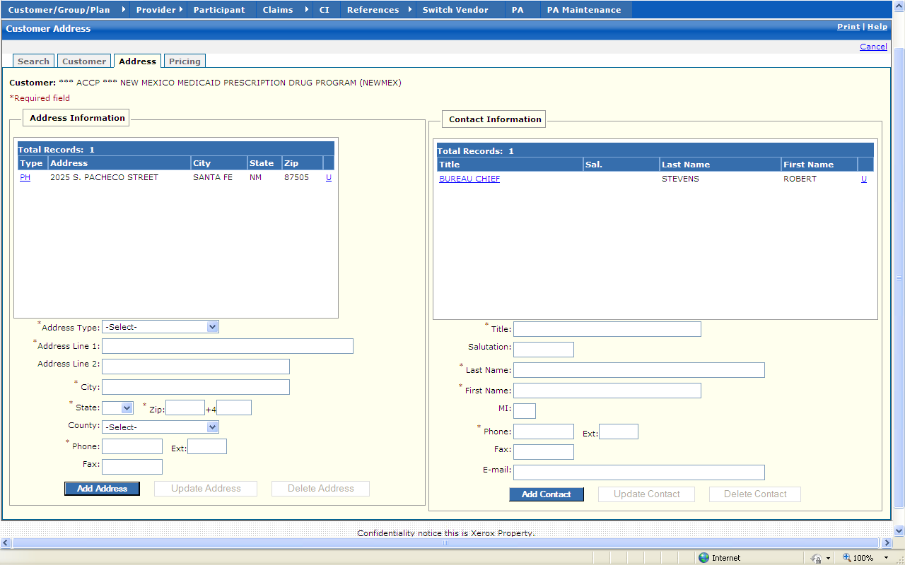

New Mexico PDCS OS PLUS Customer/Group/Plan Subsystem
Window Exhibit
Customer Functional Group
Address Tab Page
Field Name | Table Column Name | Table Name | Format | Prot. (A,C,N) | Req.  (A,C,N) | Std. Edits | Specifications | Note  Ref.
Customer | R_CUST_NAM & R_CUST_ID | R_CUST_DTL_TB | Display | A | N | N/A | This field is populated based on the Customer ID chosen upon login.
Address Information Display | Group | N/A | N/A | N/A | N/A | N/A
Type | G_ADR_TY_CD | R_CUST_ADR_TB | X (2) | A | N | N/A
Address | G_ADR_LINE1_AD | R_CUST_ADR_TB | X (50) | A | N | N/A
City | G_ADR_CITY_NAME | R_CUST_ADR_TB | X (30) | A | N | N/A
State | G_ADR_STATE_CD | R_CUST_ADR_TB | X (2) | A | N | N/A
Zip | G_ADR_ZIP5_CD | R_CUST_ADR_TB | X (5) | A | N | N/A
Total Records | N/A | N/A | Display | A | N | N/A | Computed
Address Information Entry | Group | N/A | N/A | N/A | N/A | N/A
Address Type | G_ADR_TY_CD | R_CUST_ADR_TB | Drop-down | N | N | V | Valid Value 2439
Address Line 1 | G_ADR_LINE1_AD | R_CUST_ADR_TB | X (50) | N | A | N/A
Address Line 2 | G_ADR_LINE2_AD | R_CUST_ADR_TB | X (50) | N | N | N/A
City | G_ADR_CITY_NAME | R_CUST_ADR_TB | X (30) | N | A | N/A
State | G_ADR_STATE_CD | R_CUST_ADR_TB | Drop-down | N | A | V | Valid Value 2705
Zip | G_ADR_ZIP5_CD | R_CUST_ADR_TB | X (5) | N | A | N
+4 | G_ADR_ZIP4_CD | R_CUST_ADR_TB | X (4) | N | N | N
County | G_ADR_CNTY_CD | R_CUST_ADR_TB | Drop-down | N | N | V | Valid Value 8204
Phone | G_ADR_PHONE_NUM | R_CUST_ADR_TB | X (10) | N | A | N
Ext | G_ADR_PHON_EXT_NUM | R_CUST_ADR_TB | X5 | N | N | N
Fax | G_ADR_FAX_NUM | R_CUST_ADR_TB | X (10) | N | N | N
Command Buttons | Group | N/A | Button Row | N/A | N/A | N/A
Add Address | N/A | N/A | Push Button | N | N | N/A | When selected, a new address that has been entered is added to the Customer record.
Update Address | N/A | N/A | Push Button | N | N | N/A | When selected, a current address is updated with any changes entered in the selected address record.
Delete Address | N/A | N/A | Push Button | N | N | N/A | When selected, the current address record is deleted.
Contact Information Display | Group | N/A | N/A | N/A | N/A | N/A
Title | G_CONTACT_TITL_NAM | R_CUST_CONTACT_TB | X (20) | A | N | N/A
Sal. | G_CONTACT_SLTN_NAM | R_CUST_CONTACT_TB | X (10) | A | N | N/A
Last Name | G_CONTACT_LST_NAM | R_CUST_CONTACT_TB | X (30) | A | N | N/A
First name | G_CONTACT_FST_NAM | R_CUST_CONTACT_TB | X (20) | A | N | N/A
Total Records | N/A | N/A | Display | A | N | N/A | Computed
Contact Information Entry | Group | N/A | N/A | N/A | N/A | N/A
Title | G_CONTACT_TITL_NAM | R_CUST_CONTACT_TB | X (20) | N | A | N/A
Salutation | G_CONTACT_SLTN_NAM | R_CUST_CONTACT_TB | X (10) | N | N | N/A
Last Name | G_CONTACT_LST_NAM | R_CUST_CONTACT_TB | X (30) | N | A | N/A
First name | G_CONTACT_FST_NAM | R_CUST_CONTACT_TB | X (20) | N | A | N/A
MI | G_CONTACT_MI_NAM | R_CUST_CONTACT_TB | X (1) | N | N | N/A
Phone | G_ADR_PHONE_NUM | R_CUST_CONTACT_TB | X (10) | N | A | N
Ext | G_ADR_PHON_EXT_NUM | R_CUST_CONTACT_TB | X (5) | N | N | N
Fax | G_ADR_FAX_NUM | R_CUST_CONTACT_TB | X (10) | N | N | N
E-mail | G_EMAIL_AD | R_CUST_CONTACT_TB | VCHAR (128) | N | N | N/A
Command Buttons | Group | N/A | Button Row | N/A | N/A | N/A
Add Contact | N/A | N/A | Push Button | N | N | N/A | When selected, a new Contact that has been entered is added to the Contact Information record.
Update Contact | N/A | N/A | Push Button | N | N | N/A | When selected, a current Contact is updated with any changes entered in the selected Contact record.
Delete Contact | N/A | N/A | Push Button | N | N | N/A | When selected, the current Contact record is deleted.

Legend
Prot. and Req. |  | Standard Edits | Note Ref.
A = Always |  | D = Date Edit | C = Customer-specific field or functionality
C = Conditionally |  | N = Numeric Edits | R = Note Reference
N = Never |  | S = System Generated
 |  | V = Valid Value Edit
Ref. No. | Notes
NA | NA

New Mexico PDCS OS PLUS Customer/Group/Plan Subsystem
Window Specification
Customer Functional Group
Pricing Tab – Pricing Level Search Window

Window Name:
Customer: Pricing Level Search
Description:
The Pricing Level Search window appears when the user clicks on the Pricing window tab. On this window, the user can:
- Select a pricing level to review
- Click the Add Price Level/Price link to create a new pricing level
Window Type:
Response window
Navigation:
The user enters this window by clicking on the Pricing tab while in the Customer subsystem.
Interface to Other Subsystem(s):
N/A
Interface to Other Application(s):
N/A
Special Security Requirements:
N/A
Presentation Sequence(s):
N/A
Remarks:
N/A

New Mexico PDCS OS PLUS Customer/Group/Plan Subsystem
Window Layout
Customer Functional Group
Pricing Tab – Pricing Level Search Window

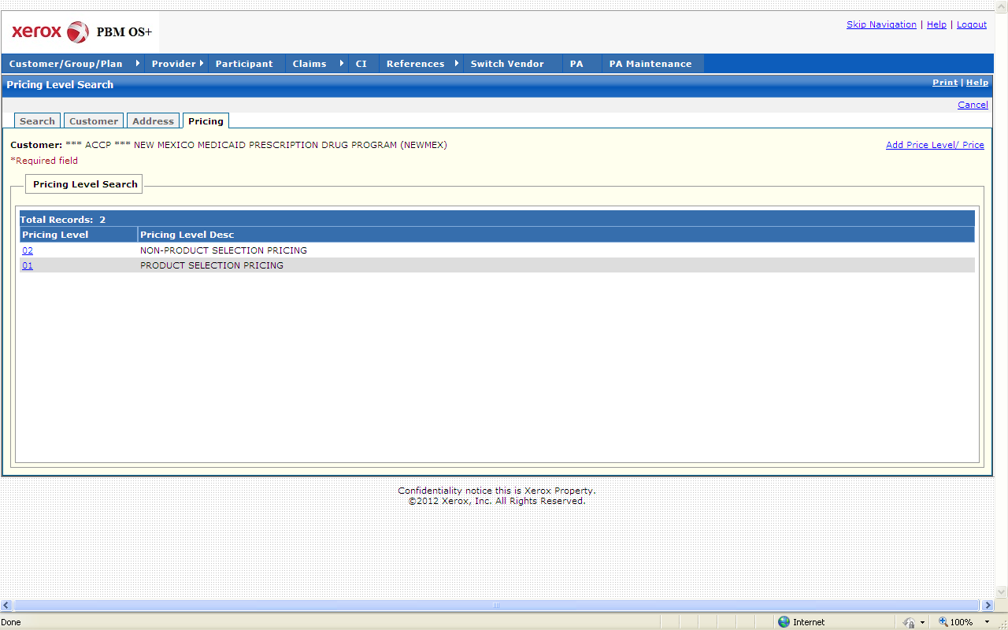

New Mexico PDCS OS PLUS Customer/Group/Plan Subsystem
Window Exhibit
Customer Functional Group
Pricing Tab – Pricing Level Search Window
Field Name | Table Column Name | Table Name | Format | Prot. (A,C,N) | Req.  (A,C,N) | Std. Edits | Specifications | Note  Ref.
Customer | R_CUST_NAM & | R_CUST_DTL_TB | Display | A | N | N/A | This field is populated based on the Customer ID chosen upon login.
Add Price Level/Price | N/A | N/A | Link | N | N | N/A | When the Add Price Level/Price link is selected, a blank Pricing Information window is presented.
Pricing Level | R_PRC_LVL_ID | R_CUST_PRC_TB | Link | A | N | N/A | The user can select a price level from the list to view in detail. When the user clicks on a price level, the Pricing Information window for that price level is displayed. On the Pricing Information window, the user can select the Price Level Search link to return to this window.
Pricing Level Desc | R_PRC_LVL_DESC | R_CUST_PRC_TB | Link | A | N | N/A
Total Records | N/A | N/A | Display | A | N | N/A | Computed

Legend
Prot. and Req. | Standard Edits | Note Ref.
A = Always | D = Date Edit | C = Customer-specific field or functionality
C = Conditionally | N = Numeric Edits | R = Note Reference
N = Never | S = System Generated
 | V = Valid Value Edit

Ref. No. | Notes

New Mexico PDCS OS PLUS Customer/Group/Plan Subsystem
Window Specification
Customer Functional Group
Pricing Tab – Pricing Information Window

Window Name:
Customer: Pricing Information
Description:
The Pricing Information window is accessible via the Pricing Level Search window.
- If a pricing level was selected, the Pricing Information window displays details specific to that pricing level. An authorized user can review and update the pricing level on this window.
- If the Add Price Level/Price link was selected, a blank Pricing Information window is presented. An authorized user can create a new pricing level on this window.
This window is used to enter, display, and update Customer pricing data .Pricing levels are created and maintained at the customer level and can then be assigned at the Group, Plan, Pharmacy Network, and Prior Authorization levels, allowing for expansive pricing customization. Every Customer pricing entry has effective date ranges .Whenever any column of data is changed, the old data should be marked with the current date as end date and a new entry made of the data with changes and the current date as begin date .The information contained on the customer file Pricing window is used as the basis for pharmacy reimbursement calculations .Pricing levels and categories allow the program maximum flexibility in claim pricing .The customer Pricing Window can contain any number of separate entries of pricing data based on date, level and category .Each row of the pricing criteria may have a separate date range.

Separate pricing methodologies can be set for each submitted Dispense As Written (DAW) code (NCPDP’s standard dispense-as-written codes that indicate why a multi-source brand named medication is dispensed when a generic product is available) .This functionality allows the patient to be assessed additional charges, if desired by the customer, for choosing the branded product when a generic is available .Each category can have dispensing fees that are defined as an amount or percentage .Setting the “Provider Override” field on the Group Pricing Window allows the dispensing fee to be taken from the pharmacy provider table instead of the group table .Current functionality allows any number of pricing options per category/DAW code combination .Additionally, the customer Pricing table allows submission and calculation of applicable sales tax for claims in those areas that require sales tax collection for prescription drugs.

To change a Customer’s pricing data, an end date must be entered on the current list and a new entry is made for the new pricing data.
Window Type:
Response window
Navigation:
The user enters this window via the Pricing Level Search Window (accessible from the Pricing tab in the Customer subsystem).
Interface to Other Subsystem(s):
N/A
Interface to Other Application(s):
N/A
Special Security Requirements:
Add, Update, and Delete functionality for pricing information is restricted to authorized users.
Presentation Sequence(s):
N/A
Remarks:
N/A

New Mexico PDCS OS PLUS Customer/Group/Plan Subsystem
Window Layout
Customer Functional Group
Pricing Tab – Pricing Information Window

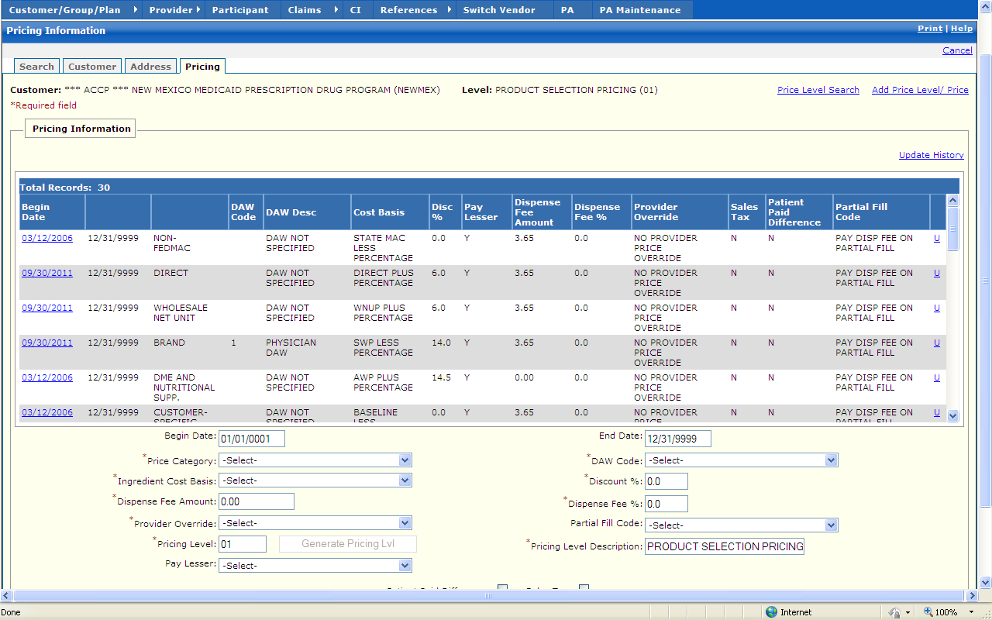
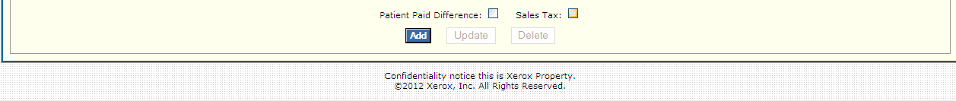

New Mexico PDCS OS PLUS Customer/Group/Plan Subsystem
Window Exhibit
Customer Functional Group
Pricing Tab – Pricing Information Window

Field Name | Table Column Name | Table Name | Format | Prot. (A,C,N) | Req.  (A,C,N) | Std. Edits | Specifications | Note  Ref.
Customer | R_CUST_NAM & R_CUST_ID | R_CUST_DTL_TB | Display | A | N | N/A | This field is populated based on the Customer ID chosen upon login.
Level | R_GRP_NAM & R_GROUP_ID | R_GROUP_DTL_  TB | Display | A | N | N/A | These fields are populated based on the Group ID chosen in the Group subsystem
Price Level Search | N/A | N/A | Link | N | N | N/A | When the Price Level Search link is selected, the Pricing Level Search page opens and existing price levels are displayed. The user can select price levels to view in detail from the list.
Add Price Level/Price | N/A | N/A | Link | N | N | N/A | When the Add Price Level/Price link is selected, a blank Pricing Information window is presented.
Pricing Information Display | Group | N/A | N/A | N/A | N/A | N/A | Grouping
Begin Date | R_GPR_PRC_BEG_DT | R_CUST_PRC_TB | DATE | A | N | N/A | Must be a valid date
End Date | R_GPR_PRC_END_DT | R_CUST_PRC_TB | DATE | A | N | N/A | Must be a valid date
Price Category | R_GPR_PRICE_CAT_CD | R_CUST_PRC_TB | X (1) | A | N | N/A | Valid Value 0128
DAW Code | R_GPR_PRICE_DAW_CD | R_CUST_PRC_TB | X (1) | A | N | N/A | Valid Value 0131
DAW Desc | R_VALD_VALU_DESC | R_VALD_VALU_TB | VCHAR (50) | A | N | N/A
Cost Basis | R_COST_BASIS_CD | R_CUST_PRC_TB | X (1) | A | N | N/A | Valid Value 0132
Disc % | R_COST_DISCT_PCT | R_CUST_PRC_TB | 999.99 | A | N | N/A
Pay Lesser | R_PAY_LESSER_IND | R_CUST_PRC_TB | X (1) | A | N | N/A | Valid Value 0141
Dispense Fee Amount | R_GPR_DISP_FEE_AMT | R_CUST_PRC_TB | 999,999,999.99 | A | N | N/A
Dispense Fee % | R_GPR_DISP_FEE_PCT | R_CUST_PRC_TB | 999.99 | A | N | N/A
Provider Override | R_GPR_PROV_OVRD_  CD | R_CUST_PRC_TB | X (1) | A | N | N/A | Valid Value 0136
Sales Tax | R_SALES_TAX_IND | R_CUST_PRC_TB | X (1) | A | N | N/A
Patient Paid Difference | R_GPR_PD_DIFF_IND | R_CUST_PRC_TB | X (1) | A | N | N/A | Valid Values 0149
Partial Fill Code | R_GPR_PART_FILL_CD | R_CUST_PRC_TB | X (1) | A | N | N/A | Valid Values List 5033
Total Records | N/A | N/A | Display | A | N | N/A | Computed
Pricing Information Entry | Group | N/A | N/A | N/A | N/A | N/A | Grouping
Begin Date | R_GPR_PRC_BEG_DT | R_CUST_PRC_TB | DATE | A | C | D | This field is always required if any other data is entered on the row.  Format is MM/DD/CCYY .Must be a valid date .
Price Category | R_GPR_PRICE_CAT_CD | R_CUST_PRC_TB | Drop-down | N | A | V | Sort Field.  Valid Values List 0128 | R1
Ingredient Cost Basis | R_COST_BASIS_CD | R_CUST_PRC_TB | Drop-down | N | A | V | Valid Values List 0132
Dispense Fee Amount | R_GPR_DISP_FEE_AMT | R_CUST_PRC_TB | 999,999,999.99 | N | A | N | Default to 0.00
Provider Override | R_GPR_PROV_OVRD_  CD | R_CUST_PRC_TB | Drop-down | N | A | V | Valid Values List 0136
Pricing Level | R_CUST_PRC_TB | R_PRC_LVL_ID | X(2) | N | A
Command Button | Group | N/A | Button Row | N/A | N/A | N/A | Grouping
Generate Pricing Lvl | N/A | N/A | Push Button | N | N | N/A | When selected, the next available pricing level is displayed .
Pay Lesser | R_PAY_LESSER_IND | R_CUST_PRC_TB | Drop  Down | N | A | N/A | Valid Value 0141  Default to blank (no) | R2
End Date | R_GPR_PRC_END_DT | R_CUST_PRC_TB | DATE | A | C | D | This field is always required if any other data is entered on the row.  Format is MM/DD/CCYY .Must be a valid date .
DAW Code | R_GPR_PRICE_DAW_CD | R_CUST_PRC_TB | Drop-down | N | A | V | Defaults to DAW not specified.  Valid Values List 0131 | R1
Discount % | R_COST_DISCT_PCT | R_CUST_PRC_TB | 999.99 | N | A | N | Default to 0.0
Dispense Fee % | R_GPR_DISP_FEE_PCT | R_CUST_PRC_TB | 999.99 | N | A | N | Default to 0.0
Partial Fill Code | R_GPR_PART_FILL_CD | R_CUST_PRC_TB | Drop-down | N | A | V | Valid Values List 5033
Pricing Level Description | R_CUST_PRC_TB | R_PRC_LVL_DESC | X(50) | N | A
Patient Paid Difference | R_GPR_PD_DIFF_IND | R_CUST_PRC_TB | Check Box | N | N | N/A | Valid Values 0149  Default to blank (no) | R3
Sales Tax | R_SALES_TAX_IND | R_CUST_PRC_TB | Check Box | N | N | N/A | Default to blank (no) | R4
Command Buttons | Group | N/A | Button Row | N/A | N/A | N/A | Grouping
Add | N/A | N/A | Push Button | N | N | N/A | When Add Button is selected, a new pricing row that has been entered is added to the Customer record .
Update | N/A | N/A | Push Button | N | N | N/A | When selected, a current address is updated with any changes entered in the selected address record.
Delete | N/A | N/A | Push Button | N | N | N/A | When Delete Button is selected, the current pricing row is deleted.

Legend
Prot. and Req. | Standard Edits | Note Ref.
A = Always | D = Date Edit | C = Customer-specific field or functionality
C = Conditionally | N = Numeric Edits | R = Note Reference
N = Never | S = System Generated
 | V = Valid Value Edit

Ref. No. | Notes
R1 | A new row cannot be added when there is an existing record with the same Price Category and the same DAW indicator for the same period.
R2 | If Pay Lesser check box is blank, the Pay Lesser than pricing logic is not invoked .If the Pay Lesser check box is checked, then Pay Lesser pricing logic is used for this Customer.
R3 | If Patient Paid Difference check box is blank, the Patient does not pay different in cost of Brand vs. Generic products .If the check box is checked, then it indicates that the Patient is responsible for the difference in the cost of brand vs. generic.
R4 | If Sales Tax check box is blank, then sale tax is not added to the cost of the prescription .If the check box is checked, then sales tax would be part of the cost of the prescription drug.

13.2.3.2 Group Functional Group

This functional group provides the user the ability to:

- Inquire on group information
- Update group information
- Add a new group

The following tab windows are used by the Group Functional Group:

- Search
- Group
- Network
- Plans

The following data is displayed in the title bar of all tab windows (i.e., not on search windows) in this functional group:

- Customer Name
- Group (Group)

New Mexico PDCS OS PLUS Customer/Group/Plan Subsystem
Window Specification
Group Functional Group
Search Tab Page

Window Name:
Group: Search
Description:
The Group Search window is the first window that appears when the Group subsystem is selected from the Subsystem Menu .The Group Functional Group is used to reflect the windows for the MED Group for either New Mexico Medicaid Customer (NEWMEX or NMENCO) .

A Group search can be performed using Group ID or Group Name .A partial information search can also be performed using three or more characters followed by a wild card (%) .If only one group matches the search criteria entered, that record is displayed on the Group Information window.
Window Type:
Response window
Navigation:
The user enters this window by clicking the Group option on the PDCS OS PLUS subsystem menu .This window takes the user to the Group window if a single group matches the search criteria or if a group is selected from the list .If the Add Group link is clicked, the Group window is displayed next.
Interface to Other Subsystem(s):
N/A
Interface to Other Application(s):
N/A
Special Security Requirements:
Authority to add groups is required to access the Add Group link.
Presentation Sequence(s):
The Search by criteria determines the initial sequence of data presented.
Remarks:
The user can select Group records using a combination of the following criteria:

Complete/Partial Customer ID

Complete/Partial Group ID

Partial searches (entering partial data from the above criteria) returns all records that have criteria equal to and greater than the last character, but not greater than the other characters .To locate a single existing record, the above criteria must be entered completely, and if a matching record is found it is displayed in the Main Window.

New Mexico PDCS OS PLUS Customer/Group/Plan Subsystem
Window Layout
Group Functional Group
Search Tab Page

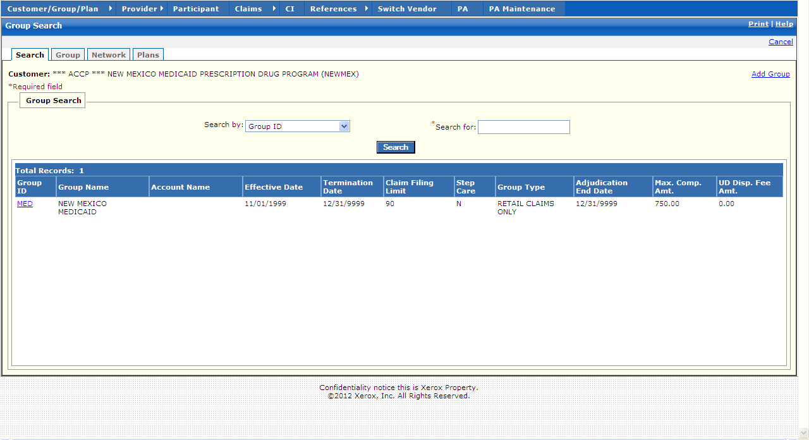

New Mexico PDCS OS PLUS Customer/Group/Plan Subsystem
Window Exhibit
Group Functional Group
Search Tab Page
Field Name | Table Column Name | Table Name | Format | Prot. (A,C,N) | Req.  (A,C,N) | Std. Edits | Specifications | Note  Ref.
Customer | R_CUST_NAM & R_CUST_ID | R_CUST_DTL_TB | Display | A | N | N/A | This field is populated based on the Customer ID chosen upon login.
Add Group | N/A | N/A | Link | N | N | N/A | By selecting Add Group Link, a blank Group window is presented for update.
Group Search Information | Group | N/A | Free Form | N/A | N/A | N/A | Grouping
Group ID | R_GROUP_ID | R_GROUP_DTL_TB | X (8) | A | N | N/A
Group Name | R_GRP_NAM | R_GROUP_DTL_TB | X (50) | A | N | N/A
Account Name | R_GRP_ACCT_NAM | R_GROUP_DTL_TB | X (30) | A | N | N/A
Effective Date | R_GRP_BEG_DT | R_GROUP_DTL_TB | DATE | A | N | N/A | Must be a valid date
Termination Date | R_GRP_END_DT | R_GROUP_DTL_TB | DATE | A | N | N/A | Must be a valid date
Claim Filing Limit | R_GRP_CLM_FILE_LMT | R_GROUP_DTL_TB | 999,999,999 | A | N | N/A
Step Care | R_GRP_STEP CARE_IND | R_GROUP_DTL_TB | X (1) | A | N | N/A
Group Type | R_GRP_TYP_CD | R_GROUP_DTL_TB | X (1) | A | N | N/A | Valid Values List 0093
Adjudication End Date | R_GRP_END_ADJUD_DT | R_GROUP_DTL_TB | DATE | A | N | N/A | Must be a valid date
Max. Comp. Amt. | R_MAX_COMPOUND_AMT | R_GROUP_DTL_TB | 999,999,999.99 | A | N | N/A
UD Disp Fee Amt | R_UD_DISP_FEE_AMT | R_GROUP_DTL_TB | 999,999,999.99 | A | N | N/A
Total Records | N/A | N/A | Display | A | N | N/A | Computed
Search Entry Group | Group | N/A | Free Form | N/A | N/A | N/A | Grouping
Search by | N/A | N/A | Drop-down | N | N | N/A | Search by defaults to Group ID .Group Name is the other search criteria.
Search for | N/A | N/A | N/A | N | A | N/A | This field is required .A % can be used as a wildcard. | R1
Command Button | Group | N/A | Button Row | N/A | N/A | N/A
Search | N/A | N/A | Push Button | N | N | N/A | When selected, this button searches the Group database to match the criteria entered in the Search by and the Search for criteria fields.

Legend
Prot. and Req. | Standard Edits | Note Ref.
A = Always | D = Date Edit | C = Customer-specific field or functionality
C = Conditionally | N = Numeric Edits | R = Note Reference
N = Never | S = System Generated
 | V = Valid Value Edit

Ref. No. | Notes
R1 | When searching on Group Name, a partial search can be invoked by entering the first character of the name and % .For example, if the user knows the Group Name starts with an “M”, the user could enter M% .All Group Name entries found on the database that start with an “M” would be displayed on the selection window .From list displayed, the user could select the appropriate Group .If only one Group was found, the record would automatically be displayed.

New Mexico PDCS OS PLUS Customer/Group/Plan Subsystem
Window Specification
Group Functional Group
Group Tab Page

Window Name:
Group: Group
Description:
The Group window is the first window that appears when the Group is selected from the Group Search window .It contains general identifying information about the Group .One or more Groups may be associated with a customer .Each Group contains one or more plans .This window contains information such as Group name and address, effective date, claim filing limit, maximum compound drug amount, additional unit dose dispensing fee, step care and FFP indicators, and contact information .The user may select to add a new Group from this window.

This window is divided into three areas called Group, Contact, and Address .The Group Information pane is used to record key Group information including name, account name, group type, and claim filing limit .Pricing levels can be assigned at this level as well, providing an additional layer of customization .The Contact Information pane is used to record name and phone information for the Group contact .
The Address Information pane is used to record the address information for the group .

Clicking the Add Group link clears the fields on the Group window.
Window Type:
Response window
Navigation:
The user enters this window by either entering search criteria that are unique for a group on the Group Search window, by selecting a group from the Group Search list or by clicking on the Group tab while on any of the Group subsystem windows .Clicking on the Show Last Update link displays the Update Information window .Clicking on the Add Group link clears the fields on the Group window .The Group window displays after the Save button is clicked.
Interface to Other Subsystem(s):
EDMS
Interface to Other Application(s):
N/A
Special Security Requirements:
Save, Add, Update, and Delete functionality for Group, Contact, and Address information is restricted to authorized users.
Presentation Sequence(s):
N/A
Remarks:
N/A

New Mexico PDCS OS PLUS Customer/Group/Plan Subsystem
Window Layout
Group Functional Group
Group Tab Page

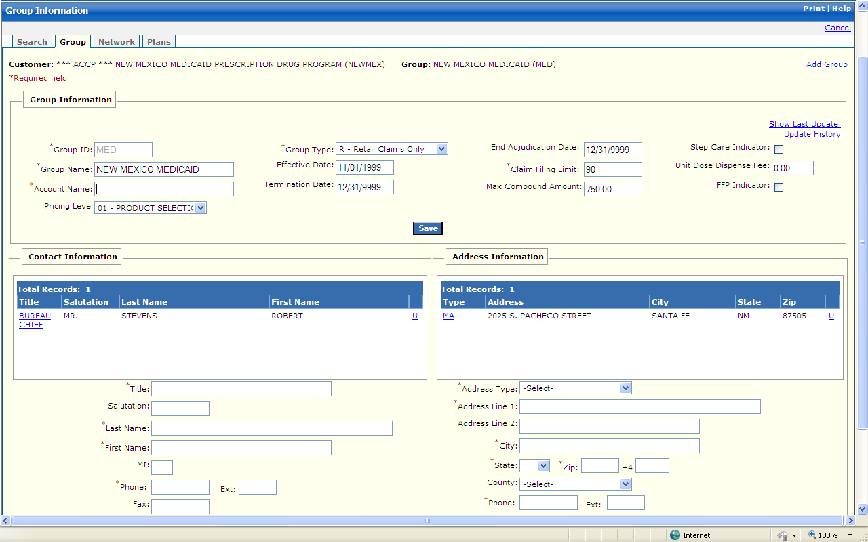
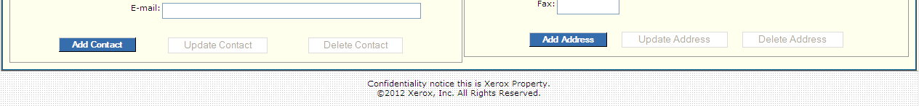

New Mexico PDCS OS PLUS Customer/Group/Plan Subsystem
Window Exhibit
Group Functional Group
Group Tab Page
Field Name | Table Column Name | Table Name | Format | Prot. (A,C,N) | Req.  (A,C,N) | Std. Edits | Specifications | Note  Ref.
Customer | R_CUST_NAM & R_CUST_ID | R_CUST_DTL_TB | Display | A | N | N/A | This field is populated based on the Customer ID chosen upon login.
Group | R_GRP_NAM & R_GROUP_ID | R_GROUP_DTL_  TB | Display | A | N | N/A | These fields are populated based on the Group ID chosen in the Group subsystem
Add Group | N/A | N/A | Link | N | N | N/A | Link allows authorized users to enter new Group records.
Group Information | Group | N/A | Free Form | N/A | N/A | N/A | Grouping
Show Last Update |  |  | Link |  |  | N/A | By selecting the Show Last Update Link, a pop-up window is displayed showing User ID, Date and Time of when the record was initially created, and when it was last updated.
Group ID | R_GROUP_ID | R_GROUP_DTL_  TB | X (8) | N | A | N | Must be a unique ID
Group Name | R_GRP_NAM | R_GROUP_DTL_  TB | X (50) | N | A | N/A
Account Name | R_GRP_ACCT_NAM | R_GROUP_DTL_  TB | X (30) | N | A | N
Pricing Level | R_CUST_PRC_TB | R_PRC_LVL_ID | Drop-down | N | N
Group Type | R_GRP_TYP_CD | R_GROUP_DTL_  TB | Drop-down | N | A | V | Valid Values List 0093
Effective Date | R_GRP_BEG_DT | R_GROUP_DTL_  TB | DATE | A | C | D | This field is always required if any other data is entered on the row.  Format is MM/DD/CCYY .Must be a valid date .
Termination Date | R_GRP_END_DT | R_GROUP_DTL_  TB | DATE | A | C | D | This field is always required if any other data is entered on the row.  Format is MM/DD/CCYY .Must be a valid date . | R3
End Adjudication Date | R_GRP_END_ADJUD_DT | R_GROUP_DTL_  TB | DATE | A | C | D | This field is always required if any other data is entered on the row.  Format is MM/DD/CCYY .Must be a valid date .. | R1
Claim Filing Limit | R_GRP_CLM_FILE_LMT | R_GROUP_DTL_  TB | 999,999,999 | N | A | N
Max Compound Amount | R_MAX_COMPOUND_  AMT | R_GROUP_DTL_  TB | 999,999,999.99 | N | N | N | Default set to 999.99
Step Care Indicator | R_GRP_STEP CARE_IND | R_GROUP_DTL_  TB | Check Box | N | N | V | Valid Values List 0120 | R2
Unit Dose Dispense Fee | R_UD_DISP_FEE_AMT | R_GROUP_DTL_  TB | 999,999,999.99 | N | N | N | Default set to 999.99
FFP Indicator | R_GRP_FFP_IND | R_GROUP_DTL_  TB | Check Box | N | N | N/A |  | R4
Command Button | Group | N/A | Button Row | N/A | N/A | N/A
Save | N/A | N/A | Push Button | N | N | N/A | Upon Saving, any additional validation is completed .Once all data passes validation, the record is saved.
Contact Information Display | Group | N/A | Free Form | N/A | N/A | N/A | Grouping
Title | G_CONTACT_TITL_NAM | R_GROUP_CONTACT_TB | X (20) | A | N | N/A
Salutation | G_CONTACT_SLTN_NAM | R_GROUP_CONTACT_TB | X (10) | A | N | N/A
Last Name | G_CONTACT_LST_NAM | R_GROUP_CONTACT_TB | X (30) | A | N | N/A
First name | G_CONTACT_FST_NAM | R_GROUP_CONTACT_TB | X (20) | A | N | N/A
Total Records | N/A | N/A | Display | A | N | N/A | Computed
Contact Information Entry | Group | N/A | Free Form | N/A | N/A | N/A | Grouping
Title | G_CONTACT_TITL_NAM | R_GROUP_CONTACT_TB | X (20) | N | A | N/A | Required field if contact entry is made.
Salutation | G_CONTACT_SLTN_NAM | R_GROUP_CONTACT_TB | X (10) | N | N | N/A
Last Name | G_CONTACT_LST_NAM | R_GROUP_CONTACT_TB | X (30) | N | A | N/A | Required field if contact entry is made.
First name | G_CONTACT_FST_NAM | R_GROUP_CONTACT_TB | X (20) | N | A | N/A | Required field if contact entry is made.
MI | G_CONTACT_MI_NAM | R_GROUP_CONTACT_TB | X (1) | N | N | N/A
Phone | G_ADR_PHONE_NUM | R_GROUP_CONTACT_TB | X (10) | N | A | N | Required field if contact entry is made.
Ext | G_ADR_PHON_EXT_NUM | R_GROUP_CONTACT_TB | X (5) | N | N | N
Fax | G_ADR_FAX_NUM | R_GROUP_CONTACT_TB | X (10) | N | N | N
E-mail | G_EMAIL_AD | R_GROUP_CONTACT_TB | VCHAR (128) | N | N | N/A
Command Buttons | Group | N/A | Button Row | N/A | N/A | N/A
Add Contact | N/A | N/A | Push Button | N | N | N/A | When selected, a new Contact that has been entered is added to the Contact record.
Update Contact | N/A | N/A | Push Button | N | N | N/A | When selected, a current Contact is updated with any changes entered in the selected Contact record.
Delete Contact | N/A | N/A | Push Button | N | N | N/A | When selected, the current Contact record is deleted.
Address Information Display | Group | N/A | N/A | N/A | N/A | N/A
Type | G_ADR_TY_CD | R_GROUP_ADR_TB | Drop-down | A | N | N/A | Valid Values List 2439
Address | G_ADR_LINE1_AD | R_GROUP_ADR_TB | X (50) | A | N | N/A
City | G_ADR_CITY_NAME | R_GROUP_ADR_TB | X (30) | A | N | N/A
State | G_ADR_STATE_CD | R_GROUP_ADR_TB | X (2) | A | N | N/A | Valid Values List 2705
Zip | G_ADR_ZIP5_CD | R_GROUP_ADR_TB | X (5) | A | N | N/A
Total Records | N/A | N/A | Display | A | N | N/A | Computed
Address Information Entry | Group | N/A | N/A | N/A | N/A | N/A
Address Type | G_ADR_TY_CD | R_GROUP_ADR_TB | Drop-down | N | N | V | Required Field if Address entry is made.  Valid Values List 2439
Address Line 1 | G_ADR_LINE1_AD | R_GROUP_ADR_TB | X (30) | N | A | N/A | Required Field if Address entry is made.
Address Line 2 | G_ADR_LINE2_AD | R_GROUP_ADR_TB | X (50) | N | N | N/A
City | G_ADR_CITY_NAME | R_GROUP_ADR_TB | X (30) | N | A | N/A | Required Field if Address entry is made.
State | G_ADR_STATE_CD | R_GROUP_ADR_TB | Drop-down | N | A | V | Required Field if Address entry is made.  Valid Values List 2705
Zip | G_ADR_ZIP5_CD | R_GROUP_ADR_TB | X (5) | N | A | N | Required Field if Address entry is made.
+4 | G_ADR_ZIP4_CD | R_GROUP_ADR_TB | X (4) | N | N | N
County | G_ADR_CNTY_CD | R_GROUP_ADR_TB | Drop-down | N | N | V | Valid Values List 8204
Phone | G_ADR_PHONE_NUM | R_GROUP_ADR_TB | X (10) | N | A | N | Required Field if Address entry is made.
Ext | G_ADR_PHON_EXT_NUM | R_GROUP_ADR_TB | X (5) | N | N | N
Fax | G_ADR_FAX_NUM | R_GROUP_ADR_TB | X (10) | N | N | N
E-mail | G_EMAIL_AD | R_GROUP_ADR_TB | VCHAR (128) | N | N | N
Command Buttons | Group | N/A | Button Row | N/A | N/A | N/A
Add Address | N/A | N/A | Push Button | N | N | N/A | When selected, a new address that has been entered is added to the Group record.
Update Address | N/A | N/A | Push Button | N | N | N/A | When selected, a current address is updated with any changes entered in the selected address record.
Delete Address | N/A | N/A | Push Button | N | N | N/A | When selected, the current address record is deleted.

Legend
Prot. and Req. | Standard Edits | Note Ref.
A = Always | D = Date Edit | C = Customer-specific field or functionality
C = Conditionally | N = Numeric Edits | R = Note Reference
N = Never | S = System Generated
 | V = Valid Value Edit

Ref. No. | Notes
R1 | If End Adjudication Date is present, it must be later than or equal to Effective Date .If the End adjudication Date is earlier that the Effective Date, the system generates error message: “The End Adjudication Date is before the Effective Date .Change one of the dates.”
R2 | When Step Care box is checked, this indicates that Step Care program applies to this Group.
R3 | If Termination Date is present, it must be later than or equal to Effective Date .If the Termination Date is earlier than the Effective Date, the system generates the following error message: “The Termination Date is before the Effective Date .Change one of the dates.”
R4 | If FFP checkbox is checked, this indicates that Group participates in Federal Financial program.

New Mexico PDCS OS PLUS Customer/Group/Plan Subsystem
Window Specification
Group Functional Group
Network Tab Page

Window Name:
Group: Network
Description:
The Network window appears when the clicking on the Network window tab .This window is used to assign one or more networks to a group .Networks can be assigned within date ranges .A short and long description is carried to identify the network.

The Assigned pane is used to view networks assigned to groups .It is also used to end date the network.

The Available pane is used to add, update, and delete networks from the pool of system-wide networks.
Window Type:
Response window
Navigation:
The user enters this window by clicking on the Network tab while in the Group subsystem.
Interface to Other Subsystem(s):
N/A
Interface to Other Application(s):
N/A
Special Security Requirements:
Save, Add, Update, and Delete Network functionality for Network information is restricted to authorized users.
Presentation Sequence(s):
N/A
Remarks:
N/A

New Mexico PDCS OS PLUS Customer/Group/Plan Subsystem
Window Layout
Group Functional Group
Network Tab Page

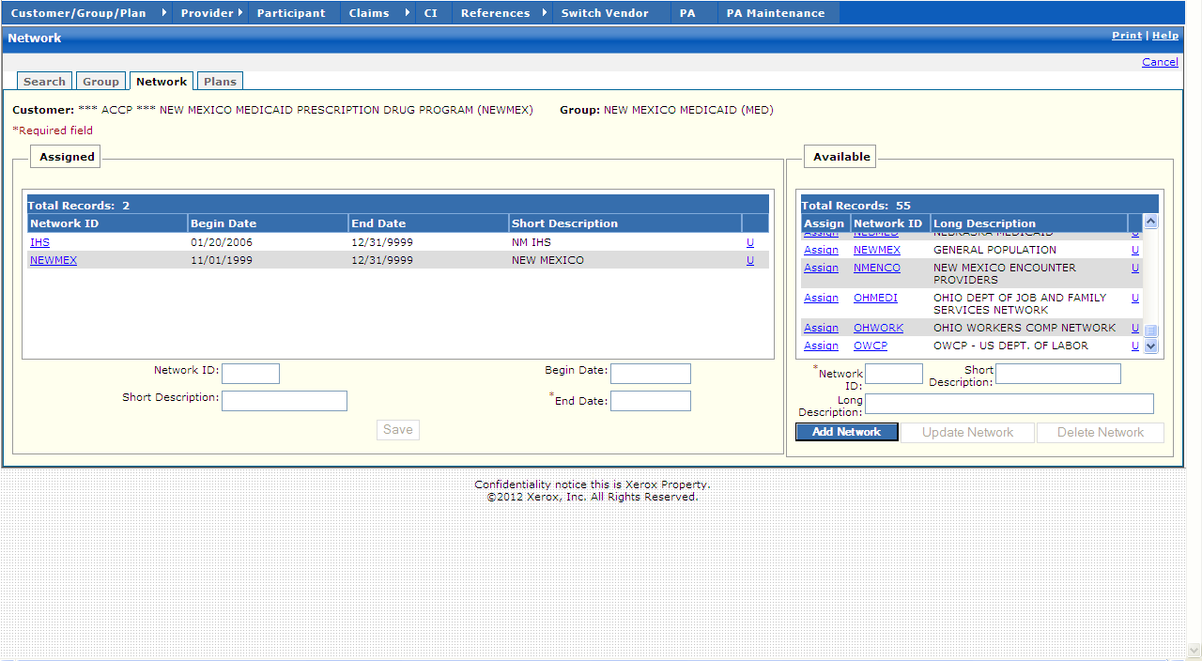

New Mexico PDCS OS PLUS Customer/Group/Plan Subsystem
Window Exhibit
Group Functional Group
Network Tab Page
Field Name | Table Column Name | Table Name | Format | Prot. (A,C,N) | Req.  (A,C,N) | Std. Edits | Specifications | Note  Ref.
Customer | R_CUST_NAM & | R_CUST_DTL_TB | Display | A | N | N/A | This field is populated based on the Customer ID chosen upon login.
Group | R_GRP_NAM & R_GROUP_ID | R_GROUP_DTL_  TB | Display | A | N | N/A | These fields are populated based on the Group ID chosen in the Group subsystem
Assigned Display | Group | N/A | N/A | N/A | N/A | N/A
Network ID | R_NETWORK_ID | R_NET_GRP_  XREF_TB | X (6) | A | N | N/A
Begin Date | R_ NET_GRP _BEG_DT | R_NET_GRP_  XREF_TB | DATE | A | N | N/A | Must be a valid date
End Date | R_ NET_GRP _END_DT | R_NET_GRP_  XREF_TB | DATE | A | N | N/A | Must be a valid date
Short Description | R_NET_SHORT_DESC | R_NETWORK_TB | X (10) | A | N | N/A
Total Records | N/A | N/A | Display | A | N | N/A | Computed
Assigned Entry | Group | N/A | N/A | N/A | N/A | N/A | Grouping
Network ID | R_NETWORK_ID | R_NET_GRP_  XREF_TB | X (6) | N | N | N/A | Click on Available Network on the right hand side of the window .It is moved to the Assigned box .The End Date can be updated at the bottom of the window.
Short Description | R_NET_SHORT_DESC | R_NETWORK_TB | X (10) | N | N | N/A
Begin Date | R_ NET_GRP _BEG_DT | R_NET_GRP_  XREF_TB | DATE | A | C | D | The Begin Date is defaulted to the date that the Network was moved to the Assigned Entry Box.  Must be a valid date
End Date | R_ NET_GRP _END_DT | R_NET_GRP_  XREF_TB | DATE | A | C | D | The End Date can be updated at the bottom of the window .Must be valid date | R1
Command Button | Group | N/A | Button Row | N/A | N/A | N/A
Save | N/A | N/A | Push Button | A | N | N/A | Upon Saving, any additional validation is completed .Once all data passes validation, the record is saved.
Available Display | Group | N/A | N/A | N/A | N/A | N/A
Assign | N/A | N/A | Link | A | N | N/A
Network ID | R_NETWORK_ID | R_NET_GRP_  XREF_TB | X (6) | A | N | N/A
Long Description | R_NET_LONG_DESC | R_NETWORK_TB | X (50) | A | N | N/A
Total Records | N/A | N/A | Display | A | N | N/A | Computed
Available Entry | Group | N/A | N/A | N/A | N/A | N/A
Network ID | R_NETWORK_ID | R_NET_GRP_  XREF_TB | X (6) | N | A | N/A | Required field.
Short Description | R_NET_SHORT_DESC | R_NETWORK_TB | X (10) | N | N | N/A
Long Description | R_NET_LONG_DESC | R_NETWORK_TB | X (50) | N | N | N/A
Command Buttons | Group | N/A | Button Row | N/A | N/A | N/A
Add Network | N/A | N/A | Push Button | N | N | N/A | When selected, a new Network that has been entered is added .
Update Network | N/A | N/A | Push Button | N | N | N/A | When selected, a current Network is updated with any changes entered in the selected Network record.
Delete Network | N/A | N/A | Push Button | N | N | N/A | When selected, the current Network record is deleted.

Legend
Prot. and Req. | Standard Edits | Note Ref.
A = Always | D = Date Edit | C = Customer-specific field or functionality
C = Conditionally | N = Numeric Edits | R = Note Reference
N = Never | S = System Generated
 | V = Valid Value Edit

Ref. No. | Notes
R1 | The Network End Date is the only field that can be changed in the Assigned Display Grouping .If the End Date is less than the Begin Date, the following error message is displayed: “The End Date is before the Begin Date .Change one of the dates.”

. . . . . . . . . . . . . . . . . . . .
New Mexico PDCS OS PLUS Customer/Group/Plan Subsystem
Window Specification
Group Functional Group
Plans Tab Page

Window Name:
Group: Plan
Description:
The Plans window appears when clicking on the Plans window tab .This window is used to assign plans to a group .This window has two areas: Assigned and Available .Listed on the right in the “Available” area are plans that exist for this group .Listed on the left side in the “Assigned” area are plans that have been assigned to this Group and written in the RPGXRFTB (plan/group Cross-Customer/Group/Plan table) .Plans are assigned to a Group by highlighting an available plan and clicking the Left arrow .Plans are unassigned from a Group by highlighting an assigned plan and clicking the right arrow.

The Group Plans Window contains the list of valid plans for the Group .This window can hold any number of plans .A participant may have overlapping eligibility spans in more than one plan for any given time period .Separate plans are usually set up for a group to define varying benefit coverage .Valid plan information on this window includes plan number, plan begin date and plan name.
Window Type:
Response window
Navigation:
The user enters this window by clicking on the Plans tab while in the Group subsystem.
Interface to Other Subsystem(s):
N/A
Interface to Other Application(s):
N/A
Special Security Requirements:
Save and Assign functionality for group plan information is restricted to authorized users.
Presentation Sequence(s):
N/A
Remarks:
N/A

New Mexico PDCS OS PLUS Customer/Group/Plan Subsystem
Window Layout
Group Functional Group
Plans Tab Page

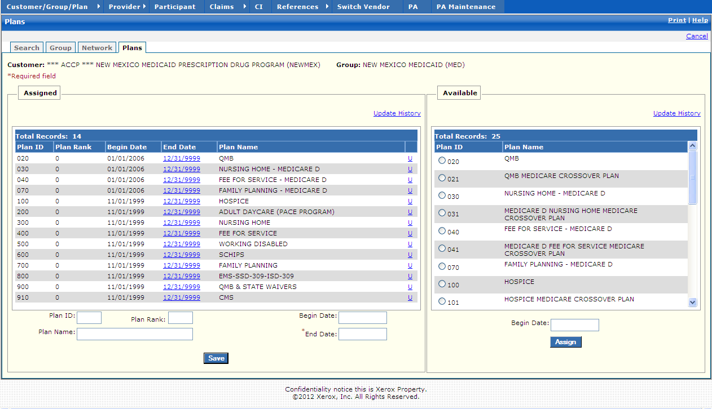

New Mexico PDCS OS PLUS Customer/Group/Plan Subsystem
Window Exhibit
Group Functional Group
Plans Tab Page
Field Name | Table Column Name | Table Name | Format | Prot. (A,C,N) | Req.  (A,C,N) | Std. Edits | Specifications | Note  Ref.
Customer | R_CUST_NAM & | R_CUST_DTL_TB | Display | A | N | N/A | This field is populated based on the Customer ID chosen upon login.
Group | R_GRP_NAM & R_GROUP_ID | R_GROUP_DTL_  TB | Display | A | N | N/A | These fields are populated based on the Group ID chosen in the Group subsystem
Assigned Display | Group | N/A | N/A | N/A | N/A | N/A | Grouping
Plan ID | R_PLAN_ID | R_PLAN_GRP_XREF_TB | X (3) | A | N | N/A
Plan Rank | R_GRP_PLN_RNK_NUM | R_PLAN_GRP_XREF_TB
Begin Date | R_PLN_GPR_BEG_DT | R_PLAN_GRP_XREF_TB | DATE | A | N | N/A
End Date | R_PLN_GRP_END_DT | R_PLAN_GRP_XREF_TB | DATE | A | N | N/A
Plan Name | R_PLAN_NAM | R_PLAN_DTL_TB | X (50) | A | N | N/A
Total Records | N/A | N/A | Display | A | N | N/A | Computed
Assigned Entry | N/A | N/A | Free Form | N/A | N/A | N/A | Grouping
Plan ID | R_PLAN_ID | R_PLAN_GRP_XREF_TB | X (3) | N | N | N/A
Plan Rank | R_GRP_PLN_RNK_NUM | R_PLAN_GRP_XREF_TB
Plan Name | R_PLAN_NAM | R_PLAN_DTL_TB | X (50) | N | N | N/A
Begin Date | R_PLN_GPR_BEG_DT | R_PLAN_GRP_XREF_TB | DATE | A | C | D | This field is always required if any other data is entered on the row.  Format is MM/DD/CCYY .Must be a valid date .
End Date | R_PLN_GRP_END_DT | R_PLAN_GRP_XREF_TB | DATE | A | A | D | This field is always required if any other data is entered on the row.  Format is MM/DD/CCYY .Must be a valid date . | R1
Command Button | Group | N/A | Button Row | N/A | N/A | N/A
Save | N/A | N/A | Push Button | N | N | N/A | Upon Saving, any additional validation is completed .Once all data passes validation, the record is saved.
Available Display | Group | N/A | Free Form | N/A | N/A | N/A | Grouping
Plan ID | R_PLAN_ID | R_PLAN_GRP_XREF_TB | X (3) | N | N | N/A |  | R2
Plan Name | R_PLAN_NAM | R_PLAN_DTL_TB | X (50) | N | N | N/A |  | R3
Total Records | N/A | N/A | Display | A | N | N/A | Computed
Available Entry | Group | N/A | Free Form | N/A | N/A | N/A | Grouping
Begin Date | R_PLN_GPR_BEG_DT | R_PLAN_GRP_XREF_TB | DATE | A | C | D | This field is always required if any other data is entered on the row.  Format is MM/DD/CCYY .Must be a valid date . | R4
Assign | N/A | N/A | Push Button | N | N | N/A

Legend
Prot. and Req. | Standard Edits | Note Ref.
A = Always | D = Date Edit | C = Customer-specific field or functionality
C = Conditionally | N = Numeric Edits | R = Note Reference
N = Never | S = System Generated
 | V = Valid Value Edit

Ref. No. | Notes
R1 | The Plan ID End Date is the only field that can be changed in the Assigned Grouping.
R2 | The Plan ID is selected by clicking on the radio button .New Plans are entered via the Plan file.
R3 | The Plan Name is associated with the Plan ID that has been selected via the radio button .Changes to the Plan Name would be made via the Plan file.
R4 | When attempting to insert a Plan where it already exists for the same date, an error message is returned as follows: “The Plan selected exists in the Assigned table with a current date .You may modify the End Date of that Plan in the Assigned pane.”

13.2.3.3 Plan Functional Group

This functional group provides the user the ability to:

- Inquire on plan information
- Update plan information
- Add a new plan

The following tab windows are used by the Plan Functional Group:

- Search
- Plan
- Detail
- Copay
- Limits
- Custom Record

The following data is displayed in the title bar of all tab windows (i.e., not on search windows) in this functional group:

- Customer Name
- Plan
- Begin Date
- End Date

New Mexico PDCS OS PLUS Customer/Group/Plan Subsystem
Window Specification
Plan Functional Group
Search Tab Page

Window Name:
Plan: Search
Description:
The Plan Search window is the first window that appears when the Plan subsystem is selected from the Customer/Group/Plan Subsystem Menu .The user may select to add a new plan or enter selection criteria to locate an existing plan.

A plan search can be performed using Plan ID or Plan Name .A partial information search can also be performed using three or more characters followed by a wild card (%) .If only one plan matches the search criteria entered, that record is displayed on the Plan Information window.
Window Type:
Response window
Navigation:
The user enters this window by clicking the Plan option on the Customer/Group/Plan subsystem menu .This window takes the user to the Plan window if a single plan matches the search criteria or if a plan is selected from the list .If the Add Plan link is clicked, a blank Plan window is displayed next.
Interface to Other Subsystem(s):
N/A
Interface to Other Application(s):
N/A
Special Security Requirements:
Authority to add plans is required to access the Add Plan link.
Presentation Sequence(s):
The Search by criteria determines the initial sequence of data presented.
Remarks:
N/A

New Mexico PDCS OS PLUS Customer/Group/Plan Subsystem
Window Layout
Plan Functional Group
Search Tab Page

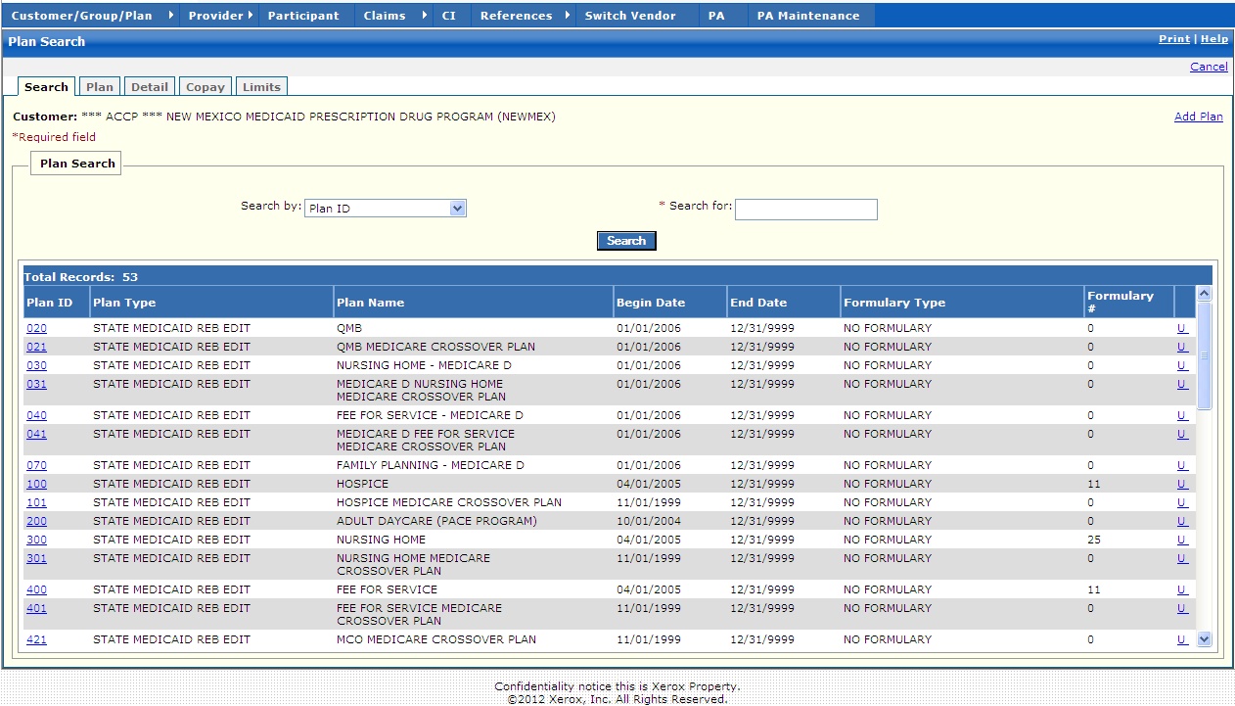

New Mexico PDCS OS PLUS Customer/Group/Plan Subsystem
Window Exhibit
Plan Functional Group
Search Tab Page
Field Name | Table Column Name | Table Name | Format | Prot. (A,C,N) | Req.  (A,C,N) | Std. Edits | Specifications | Note  Ref.
Customer | R_CUST_NAM & | R_CUST_DTL_TB | Display | A | N | N/A | This field is populated based on the Customer ID chosen upon login.
Add Plan | N/A | N/A | Link | N | N | N/A | By selecting Add Plan Link, a blank Plan window is presented for update.
Plan Search Display | Group | N/A | Free Form | N/A | N/A | N/A | Grouping
Plan ID | R_PLAN_ID | R_PLAN_DTL_TB | Drop-down | A | N | N/A |  | R1
Plan Type | R_PLAN_TYPE_CD | R_PLAN_DTL_TB | X (1) | A | N | N/A
Plan Name | R_PLAN_NAM | R_PLAN_DTL_TB | X (50) | A | N | N/A
Begin Date | R_PLN_BEG_DT | R_PLAN_DTL_TB | DATE | A | N | N/A
End Date | R_PLN_END_DT | R_PLAN_DTL_TB | DATE | A | N | N/A
Formulary Type | R_FORMULARY_TY_CD | R_PLAN_DTL_TB | X (1) | A | N | N/A
Formulary # | R_DRUG_FMLY_NUM | R_PLAN_DTL_TB | 9999 | A | N | N/A
Total Records | N/A | N/A | Display | NA/ | N/A | N/A | Computed
Plan Search Entry Group | Group | N/A | Free Form | N/A | N/A | N/A | Grouping
Search by | N/A | N/A | Drop-down | N | N | N/A | Search by defaults to Plan ID .
Search for | N/A | N/A | N/A | N | A | N/A | This field is required .A % can be used as a wildcard.
Command Buttons | Group | N/A | Button Row | N/A | N/A | N/A | Grouping
Search | N/A | N/A | Push Button | N | N | N/A | When selected, this button searches the Plan database to match the criteria entered in the Search by and the Search for criteria fields.

Legend
Prot. and Req. | Standard Edits | Note Ref.
A = Always | D = Date Edit | C = Customer-specific field or functionality
C = Conditionally | N = Numeric Edits | R = Note Reference
N = Never | S = System Generated
 | V = Valid Value Edit

Ref. No. | Notes
R1 | When searching on Plan ID, a partial search can be invoked by entering the first one or two characters of the ID and %

New Mexico PDCS OS PLUS Customer/Group/Plan Subsystem
Window Specification
Plan Functional Group
Plan Tab Page

Window Name:
Plan: Plan
Description:
The Plan window is the first window that appears when the plan is selected from the Plan Search window .This window displays general identifying information about a plan and is used to add, inquire, and update plan header data .One or more plans belong to a customer and group .Each Group contains one or more plans .Window contents include Plan name, effective begin and end dates, benefit maximums and deductibles for individuals and families, dependent information, and various codes including formulary information and DESI indicator .DAW codes are listed at the bottom .The user may select to add a new plan from this window .

The plan header window supports the calculation of maximum benefit and deductibles for individuals or by family .Plans are created for Groups to distinguish the different types of benefits within one Group .There can be any number of plans assigned to one Group .There is no practical limit to the number of plans to a group .The PDCS OS PLUS system allows multiple plan iterations with different effective dates within one plan .Plan numbers cannot repeat within the same customer. Pricing levels can be assigned at this level as well, providing an additional layer of customization.

Clicking the Add Plan link clears the fields on the Plan window.
Window Type:
Response window
Navigation:
The user enters this window from the Plan Search window by 1) clicking the Add Plan link, 2) selecting the unique Plan ID from the list, or 3) when one record matches the Search for value .The Plan window displays after the Save button is clicked.
Interface to Other Subsystem(s):
N/A
Interface to Other Application(s):
N/A
Special Security Requirements:
Save, Add, Update, and Delete DAW functionality for plan information is restricted to authorized users.
Presentation Sequence(s):
For the Dispense as Written pane, the data is initially sorted by DAW ID and can be re-sorted by End Date.
Remarks:
N/A

New Mexico PDCS OS PLUS Customer/Group/Plan Subsystem
Window Layout
Plan Functional Group
Plan Tab Page

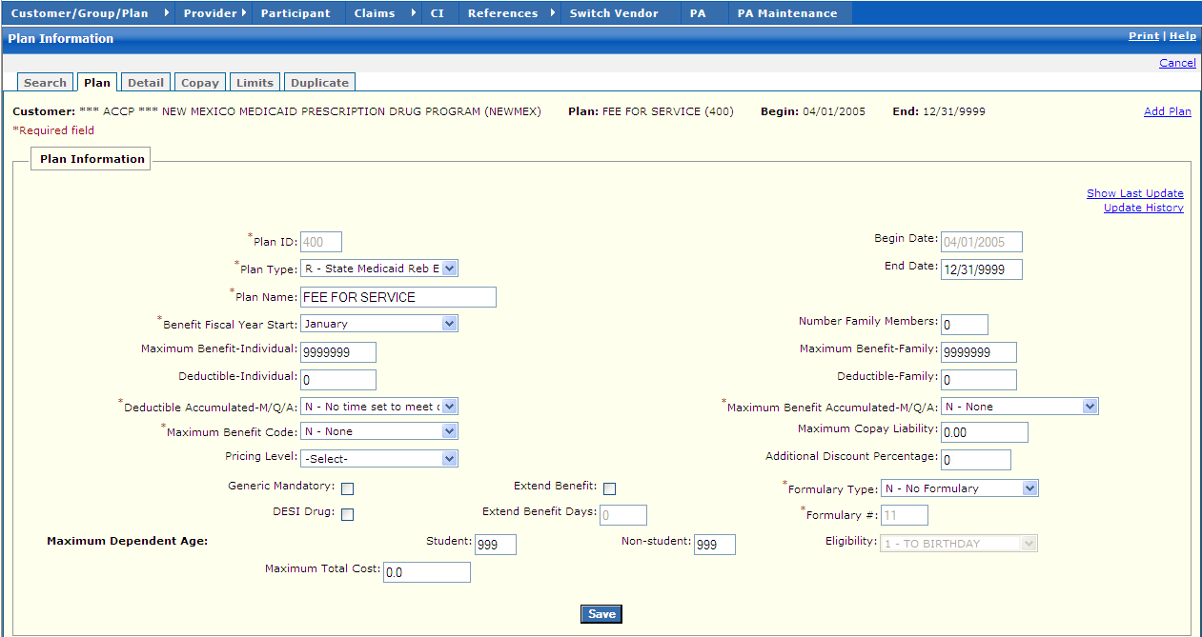

New Mexico PDCS OS PLUS Customer/Group/Plan Subsystem
Window Exhibit
Plan Functional Group
Plan Tab Page
Field Name | Table Column Name | Table Name | Format | Prot. (A,C,N) | Req.  (A,C,N) | Std. Edits | Specifications | Note  Ref.
Customer | R_CUST_NAM & | R_CUST_DTL_TB | Display | A | N | N/A | This field is populated based on the Customer ID chosen upon login.
Plan | R_PLAN_NAM & R_PLAN_ID | R_PLAN_DTL_TB | Display | A | N | N/A | These fields are populated based on the Plan ID chosen in the Plan subsystem
Begin | R_PLAN_BEG_DT | R_PLAN_DTL_TB | Display | A | N | N/A | This field is populated based on the Plan ID chosen in the Plan subsystem
End | R_PLAN_END_DT | R_PLAN_DTL_TB | Display | A | N | N/A | This field is populated based on the Plan ID chosen in the Plan subsystem
Add Plan | N/A | N/A | Link | N | N | N/A | By selecting Add Plan Link, a blank Plan window is presented for update.
Plan Information | Group | N/A | Free Form | N/A | N/A | N/A | Grouping
Show Last Update | G_AUD_USER_ID, G_AUD_TS | G_LIST_DTL_TB | X (20), Time-Stamp | A | C | N/A | By selecting the Show Last Update Link, a pop-up window is displayed showing User ID, Date and Time of when the record was initially created, and when it was last updated.
Plan ID | R_PLAN_ID | R_PLAN_DTL_TB | X (3) | N | A | V | Valid Values List 6116
Plan Type | R_PLAN_TYPE_CD | R_PLAN_DTL_TB | Drop-down | N | A | V | Valid Values List 6116
Plan Name | R_PLAN_NAM | R_PLAN_DTL_TB | X (50) | N | A | N/A
Benefit Fiscal Year Start | R_FY_BEG_MO_NUM | R_PLAN_DTL_TB | Drop-down | N | N | N/A
Maximum Benefit – Individual | R_MAX_INDIV_AMT | R_PLAN_DTL_TB | 999,999,999 | N | N | N | Default to 999999999
Deductible-Individual | R_DED_INDIV_AMT | R_PLAN_DTL_TB
Deductible Accumulated-M/Q/A | R_DED_ACUM_CD | R_PLAN_DTL_TB |  |  |  |  | Valid Values List 3406
Maximum Benefit Code | R_MAX_BENE_CD | R_PLAN_DTL_TB | Drop-down | N | A | V | Valid Values List 5857
Pricing Level | R_CUST_PRC_TB | R_PRC_LVL_ID | X(2) Drop-down | N | N
Begin Date | R_PLAN_BEG_DT | R_PLAN_DTL_TB | DATE | A | C | D | Must be a valid date
End Date | R_PLAN_END_DT | R_PLAN_DTL_TB | DATE | A | C | D | Must be a valid date
Number Family Members | R_MAX_FAM_MBR_NUM | R_PLAN_DTL_TB
Maximum Benefit-Family | R_MAX_FAM_AMT | R_PLAN_DTL_TB
Deductible-Family | R_DED_FAM_AMT | R_PLAN_DTL_TB
Max Benefit Accumulated-M/Q/A | R_MAX_BENE_ACUM_CD | R_PLAN_DTL_TB | Drop-down | N | A | V | Valid Values List 7822
Maximum Copay Liability | R_MAX_MO_COPAY_AMT | R_PLAN_DTL_TB | X (1) | N | N | N | Default to 0.00
Additional Discount Percentage | R_PLN_DISCT_PCT | R_PLAN_DTL_TB |  |  |  |  | Default to 30.00 | R3
Generic Mandatory | R_GENR_MAND_IND | R_PLAN_DTL_TB | Check Box | N | N | N/A
DESI Drug | R_DESI_DRUG_IND | R_PLAN_DTL_TB | Check Box | N | N | N/A
Extend Benefit | R_EXT_BENE_IND | R_PLAN_DTL_TB | Check Box | N | N | N/A |  | R1
Extend Benefit Days | R_EXT_BENE_DAY_  NUM | R_PLAN_DTL_TB | 9999 | N | N | N |  | R1
Formulary Type | R_FORMULARY_TY_CD | R_PLAN_DTL_TB | Drop-down | N | A | N/A |  | R2
Formulary # | R_DRUG_FMLY_NUM | R_PLAN_DTL_TB | 9999 | N | A | N |  | R2
Maximum Dependent Age (Student) | R_MAX_STUDNT_AGE | R_PLAN_DTL_TB
Maximum Dependent Age (Non-Student) | R_NON_STUDNT_AGE | R_PLAN_DTL_TB
Maximum Dependent Age (Eligibility) | R_MAX_DEP_AGE_CD | R_PLAN_DTL_TB |  |  |  |  | Valid Values List 3617
Command Button | Group | N/A | Button Row | N/A | N/A | N/A | Grouping
Save | N/A | N/A | Push Button | N | N | N/A | Upon Saving, any additional validation is completed .Once all data passes validation, the record is saved.
Dispense As Written Display | Group | N/A | Free Form | N/A | N/A | N/A | Grouping
DAW | R_PLAN_DAW_CD | R_PLAN_DAW_  TB | X (1) | A | N | N/A
Begin Date | R_DAW_BEG_DT | R_PLAN_DAW_  TB | DATE | A | N | N/A
End Date | R_DAW_END_DT | R_PLAN_DAW_  TB | DATE | A | N | N/A
Total Records | N/A | N/A | Display | A | N | N/A | Computed
Dispense As Written Entry | Group | N/A | Free Form | N/A | N/A | N/A | Grouping
DAW ID | R_PLAN_DAW_CD | R_PLAN_DAW_  TB | X (1) | N | A | N
DAW Begin Date | R_DAW_BEG_DT | R_PLAN_DAW_  TB | DATE | A | C | D | This field is always required if any other data is entered on the row.  Format is MM/DD/CCYY .Must be a valid date .
DAW End Date | R_DAW_END_DT | R_PLAN_DAW_  TB | DATE | A | C | D | This field is always required if any other data is entered on the row.  Format is MM/DD/CCYY .Must be a valid date .
Command Buttons | Group | N/A | Button Row | N/A | N/A | N/A | Grouping
Add DAW | N/A | N/A | Push Button | N | N | N/A | When selected, a new DAW that has been entered is added .
Update DAW | N/A | N/A | Push Button | N | N | N/A | When selected, a current DAW is updated with any changes entered in the selected DAW record.
Delete DAW | N/A | N/A | Push Button | N | N | N/A | When selected, the current DAW record is deleted.

Legend
Prot. and Req. | Standard Edits | Note Ref.
A = Always | D = Date Edit | C = Customer-specific field or functionality
C = Conditionally | N = Numeric Edits | R = Note Reference
N = Never | S = System Generated
 | V = Valid Value Edit

Ref. No. | Notes
R1 | When the Extend Benefit Check Box is checked, the Extended Benefit Days field is opened up for data entry .If the Extended Benefit Check Box is not checked, the Extended Benefit Days field is grayed out and not updateable.
R2 | If Formulary Type = P or C, Formulary, Formulary # field is opened for entry and requires formulary # to be entered .If the Formulary Type = N, the Formulary # field is grayed out and not updateable .
New Mexico PDCS OS PLUS Customer/Group/Plan Subsystem
Window Specification
Plan Functional Group
Detail Tab Page

Window Name:
Plan: Detail
Description:
The Detail window appears when the clicking on the Detail window tab .This window displays detail information about a plan for either retail or mail order and is used to add, inquire, and update Plan Detail data .Window contents include limits related to day supply, maintenance days, grace period, max claim amount, number of prescriptions, spans, refills ages, and copay information at the bottom .The PDCS OS PLUS system allows multiple plan detail iterations with different effective dates within one plan.
Window Type:
Response window
Navigation:
The user enters this window by clicking on the Detail tab while in the Plan portion of the Customer/Group/Plan subsystem.
Interface to Other Subsystem(s):
N/A
Interface to Other Application(s):
N/A
Special Security Requirements:
Add, Update, and Delete functionality for plan detail information is restricted to authorized users.
Presentation Sequence(s):
The plan detail data is sorted by Detail Begin Date.
Remarks:
N/A

New Mexico PDCS OS PLUS Customer/Group/Plan Subsystem
Window Layout
Plan Functional Group
Detail Tab Page

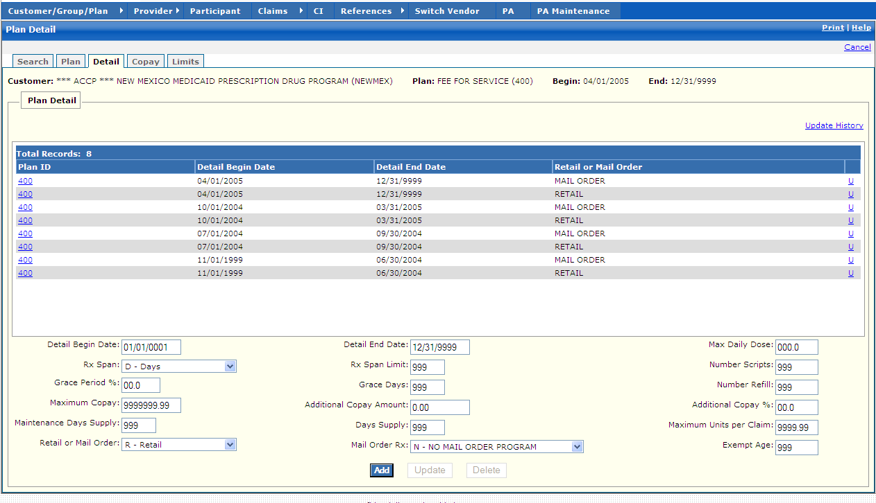

New Mexico PDCS OS PLUS Customer/Group/Plan Subsystem
Window Exhibit
Plan Functional Group
Detail Tab Page
Field Name | Table Column Name | Table Name | Format | Prot. (A,C,N) | Req.  (A,C,N) | Std. Edits | Specifications | Note  Ref.
Customer | R_CUST_NAM & | R_CUST_DTL_TB | Display | A | N | N/A | This field is populated based on the Customer ID chosen upon login.
Plan | R_PLAN_NAM & R_PLAN_ID | R_PLAN_DTL_TB | Display | A | N | N/A | These fields are populated based on the Plan ID chosen in the Plan subsystem
Begin | R_PLAN_BEG_DT | R_PLAN_DTL_TB | Display | A | N | N/A | This field is populated based on the Plan ID chosen in the Plan subsystem
End | R_PLAN_END_DT | R_PLAN_DTL_TB | Display | A | N | N/A | This field is populated based on the Plan ID chosen in the Plan subsystem
Plan Details Display | Group | N/A | Free Form | N/A | N/A | N/A | Grouping
Plan ID | R_PLAN_ID | R_PLN_HDR_LMT_TB | X (3) | A | N | N/A
Detail Begin Date | R_PHL_BEG_DT | R_PLN_HDR_LMT_TB | DATE | A | N | N/A
Detail End Date | R_PHL_END_DT | R_PLN_HDR_LMT_TB | DATE | A | N | N/A
Retail or Mail Order | R_PHL_BUSN_TYP_CD | R_PLN_HDR_LMT_TB | X (1) | A | N | N/A
Total Records | N/A | N/A | Display | A | N | N/A | Computed
Plan Details Entry | Group | N/A | Free Form | N/A | N/A | N/A | Grouping
Detail Begin Date | R_PHL_BEG_DT | R_PLN_HDR_LMT_TB | DATE | A | C | D | This field is always required if any other data is entered on the row.  Format is MM/DD/CCYY .Must be a valid date .
Rx Span | R_PHL_RX_SPAN_CD | R_PLN_HDR_LMT_TB | Drop-down | N | N | V | Default to D-Days  Valid Values List 2536
Grace Period % | R_GRACE_PER_PCT | R_PLN_HDR_LMT_TB | .999 | N | N | N | Default to 0.00
Maximum Copay | R_MAX_COPAY_AMT | R_PLN_HDR_LMT_TB | 9,999,999.99 | N | N | N | Default to 9999999.99
Maintenance Days Supply | R_MAINT_SPLY_LMT | R_PLN_HDR_LMT_TB | 9,999 | N | N | N | Default to 999
Retail or Mail Order | R_PHL_BUSN_TYP_CD | R_PLN_HDR_LMT_TB | Drop-down | N | N | V | Default to R-Retail  Valid Values List 6787
Detail End Date | R_PHL_END_DT | R_PLN_HDR_LMT_TB | DATE | A | C | D | This field is always required if any other data is entered on the row.  Format is MM/DD/CCYY .Must be a valid date .
Rx Span Limit | R_PHL_RX_SPN_LMT | R_PLN_HDR_LMT_TB | 9,999 | N | N | N | Default to 999
Grace Days | R_GRACE_DAYS_LMT | R_PLN_HDR_LMT_TB | 9,999 | N | N | N | Default to 999
Additional Copay Amount | R_ADDL_COPAY_AMT | R_PLN_HDR_LMT_TB | 9,999,999.99 | N | N | N | Default to 0.00
Days Supply | R_DAYS_SPLY_LMT | R_PLN_HDR_LMT_TB | 9,999 | N | N | N | Default to 999
Mail Order Rx | R_MAIL_ORD_RX_CD | R_PLN_HDR_LMT_TB | Drop-down | N | N | V | Defaults to N-No Mail Order Program  Valid Values List 7988
Max Daily Dose | R_MAX_CLM_UNT_LMTDECIMAL | R_PLN_HDR_LMT_TB | .999 | N | N | N | Default to 0.00
Number Scripts | R_PHL_NUM_RX_LMT | R_PLN_HDR_LMT_TB | 9,999,999.99 | N | N | N | Default to 999
Number Refill | R_NUM_REFLL_LMT | R_PLN_HDR_LMT_TB | 9,999 | N | N | N | Default to 999
Additional Copay % | R_ADDL_COPAY_PCT | R_PLN_HDR_LMT_TB | 9.9999 | N | N | N | Default to 00.0
Maximum Units per Claim | R_MAX_CLM_UNT_  LMT | R_PLN_HDR_LMT_TB | 9,999 | N | N | N | Default to 9999.99
Exempt Age | R_PHL_EXMT_AGE | R_PLN_HDR_LMT_TB | 9,999 | N | N | N | Defaults to 999
Command Buttons | Group | N/A | Button Row | N/A | N/A | N/A | Grouping
Add | N/A | N/A | Push Button | N | N | N/A | When selected, a new Plan that has been entered is added .
Update | N/A | N/A | Push Button | N | N | N/A | When selected, a current Plan is updated with any changes entered in the selected Plan record.
Delete | N/A | N/A | Push Button | N | N | N/A | When selected, the current Plan record is deleted.

Legend
Prot. and Req. | Standard Edits | Note Ref.
A = Always | D = Date Edit | C = Customer-specific field or functionality
C = Conditionally | N = Numeric Edits | R = Note Reference
N = Never | S = System Generated
 | V = Valid Value Edit

Ref. No. | Notes
N/A | N/A

New Mexico PDCS OS PLUS Customer/Group/Plan Subsystem
Window Specification
Plan Functional Group
Copay Tab Page

Window Name:
Plan: Copay
Description:
The Copay window appears when the clicking on the Copay window tab .This window displays detail information about dollar values and percentages of Copays as they relate to the selected Plan .Window contents include copay related to partial fills, copay amount, copay code, and copay percentage .The PDCS OS PLUS system allows multiple plan copay iterations with different effective dates within one plan .

The copay window is used to update and view co-pay information for a specific plan .For retail prescriptions, copayments are set in percentages or dollar amounts .Copayment amounts are broken out in the category field to generic, brand, brand no generic, non-network generic, non-network brand, non-network brand no generic, over max generic, over max brand, over max brand no generic, non-formulary, non-network, or non-formulary .The Plan Detail supports co-payment processing based on the type of drug and limits allowed by the customer.
Window Type:
Response window
Navigation:
The user enters this window by clicking on the Copay tab while in the Plan subsystem.
Interface to Other Subsystem(s):
N/A
Interface to Other Application(s):
N/A
Special Security Requirements:
Add, Update, and Delete functionality for plan copay information is restricted to authorized users.
Presentation Sequence(s):
N/A
Remarks:
N/A

New Mexico PDCS OS PLUS Customer/Group/Plan Subsystem
Window Layout
Plan Functional Group
Copay Tab Page

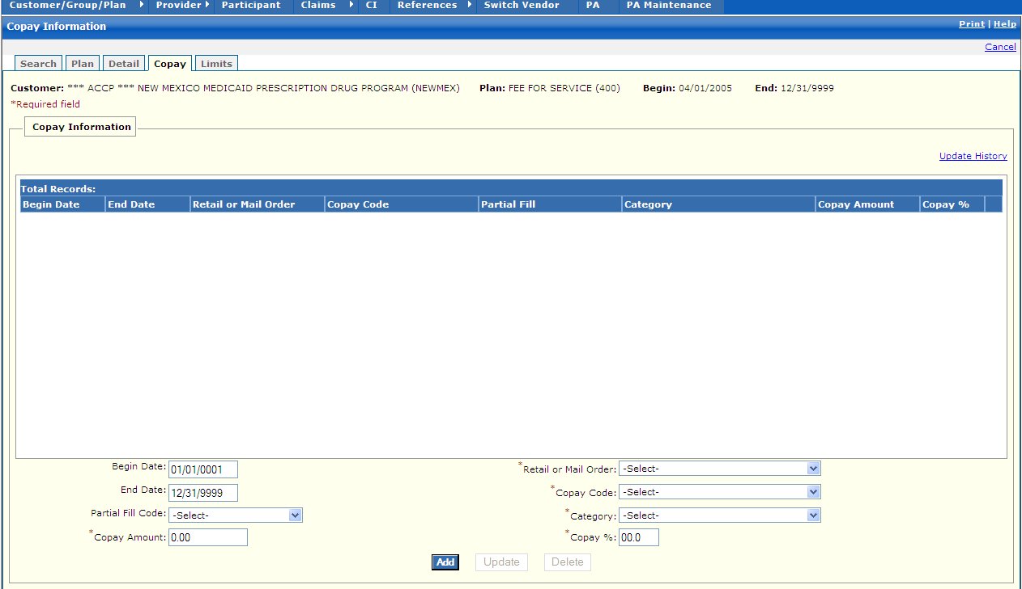

New Mexico PDCS OS PLUS Customer/Group/Plan Subsystem
Window Exhibit
Plan Functional Group
Copay Tab Page
Field Name | Table Column Name | Table Name | Format | Prot. (A,C,N) | Req.  (A,C,N) | Std. Edits | Specifications | Note  Ref.
Customer | R_CUST_NAM & | R_CUST_DTL_TB | Display | A | N | N/A | This field is populated based on the Customer ID chosen upon login.
Plan | R_PLAN_NAM & R_PLAN_ID | R_PLAN_DTL_TB | Display | A | N | N/A | These fields are populated based on the Plan ID chosen in the Plan subsystem
Begin | R_PLAN_BEG_DT | R_PLAN_DTL_TB | Display | A | N | N/A | This field is populated based on the Plan ID chosen in the Plan subsystem
End | R_PLAN_END_DT | R_PLAN_DTL_TB | Display | A | N | N/A | This field is populated based on the Plan ID chosen in the Plan subsystem
Copay Information Display | Group | N/A | Free Form | N/A | N/A | N/A | Grouping
Begin Date | R_PCC_BEG_DT | R_PLN_COPAY_CAT_  TB | DATE | A | N | N/A
End Date | R_PCC_END_DT | R_PLN_COPAY_CAT_  TB | DATE | A | N | N/A
Retail or Mail Order | R_PHL_BUSN_TYP_CD | R_PLN_COPAY_CAT_  TB | X (1) | A | N | N/A | Valid Values List 6787
Copay Code | R_PCC_COPAY_CD | R_PLN_COPAY_CAT_  TB | X (1) | A | N | N/A | Valid Values List 4338
Partial Fill | R_PCC_PART_FILL_CD | R_PLN_COPAY_CAT_  TB | X (1) | A | N | N/A | Valid Values List 1292
Category | R_PCC_CATEGORY_  CD | R_PLN_COPAY_CAT_  TB | X (2) | A | N | N/A | Valid Values List 7810
Copay Amount | R_PCC_COPAY_AMT | R_PLN_COPAY_CAT_  TB | 9,999,999.99 | A | N | N/A
Copay % | R_PCC_COPAY_PCT | R_PLN_COPAY_CAT_  TB | 9.9999 | A | N | N/A
Total Records | N/A | N/A | Display | A | N | N/A | Computed
Copay Information Entry | Group | N/A | Free Form | N/A | N/A | N/A | Grouping
Begin Date | R_PCC_BEG_DT | R_PLN_COPAY_CAT_  TB | DATE | A | C | D | This field is always required.  Format is MM/DD/CCYY .Must be a valid date.  Default to current date .
End Date | R_PCC_END_DT | R_PLN_COPAY_CAT_  TB | DATE | A | C | D | This field is always required if begin date was entered.  Format is MM/DD/CCYY .Must be a valid date . .
Partial Fill Code | R_PCC_PART_FILL_CD | R_PLN_COPAY_CAT_  TB | Drop-down | N | N | V | Valid Values List 1292
Copay Amount | R_PCC_COPAY_AMT | R_PLN_COPAY_CAT_  TB | 9,999,999.99 | N | N | N
Retail or Mail Order | R_PHL_BUSN_TYP_CD | R_PLN_COPAY_CAT_  TB | Drop-down | N | N | V | Valid Values List 6787
Copay Code | R_PCC_COPAY_CD | R_PLN_COPAY_CAT_  TB | Drop-down | N | N | V | Valid Values List 4338
Category | R_PCC_CATEGORY_  CD | R_PLN_COPAY_CAT_TB | Drop-down | N | N | V | Valid Values List 7810
Copay % | R_PCC_COPAY_PCT | R_PLN_COPAY_CAT_TB | 9.9999 | N | N | N
Command Buttons | Group | N/A | Button Row | N/A | N/A | N/A | Grouping
Add | N/A | N/A | Push Button | N | N | N/A | When selected, a new Copay that has been entered is added .
Update | N/A | N/A | Push Button | N | N | N/A | When selected, a current Copay Information is updated with any changes entered.
Delete | N/A | N/A | Push Button | N | N | N/A | When selected, the current Copay record is deleted.

Legend
Prot. and Req. | Standard Edits | Note Ref.
A = Always | D = Date Edit | C = Customer-specific field or functionality
C = Conditionally | N = Numeric Edits | R = Note Reference
N = Never | S = System Generated
 | V = Valid Value Edit

Ref. No. | Notes
N/A | N/A
New Mexico PDCS OS PLUS Customer/Group/Plan Subsystem
Window Specification
Plan Functional Group
Limits Tab Page

Window Name
Plan: Limits
Description:
The Benefit Limits window appears when the clicking on the Limits window tab .The end user can access this window to view or update benefit coverage parameters for a specific plan .A drug can be defined as covered or not covered at the following levels: generic code number, generic sequence number, NDC, therapeutic class, drug category, DEA, route code and drug class .There must be a least one row of data entered on this window for the system to accept a new Plan .The PDCS OS PLUS system allows multiple iterations of plan benefit limits with different effective dates within one plan.

The Plan Benefit Limits Window is utilized to further restrict benefits .The entries on this window allow drug coverage to be set at the plan level .Any number of Plan Benefit Limit coverage parameters can be entered on one plan .The majority of entries on this window are for noncovered drugs .The default for all benefits is to be covered .Therefore, any drug not defined as noncovered would be considered to be a covered benefit by default.

If there are too many Benefit Limits for a plan to fit on the window, there is a scroll bar to allow scrolling through all the rows entered for the plan .There is no practical limit to the number of benefit limit rows that can be put on a plan.

To create or view Benefit Limits Custom data, select a row on the Benefit Limits window by tabbing to it or clicking on it .Then click the Custom button, or tab to it and press Enter when the Custom button is highlighted.

When a new Benefit Limits record is created, the user can give it a specific priority number or it can be assigned a priority number according to the Plan Coverage Hierarchy .The user can click on the Set Default Priorities link to sort the records according to the Plan Coverage Hierarchy Logic .The ability to reprioritize rows is only available if the sort is on the “Priority” column.
Window Type:
Response window
Navigation:
The user enters this window by clicking on the Limits tab while in the Plan subsystem .Data can be resorted in tables by clicking on underlined column headings .By clicking on the heading, the data sorts in ascending or descending order.
Interface to Other Subsystem(s):
N/A
Interface to Other Application(s):
N/A
Special Security Requirements:
Add, Update, and Delete functionality for benefit limits information is restricted to authorized users.
Presentation Sequence(s):
The Benefit Limit data is initially sorted by Priority .The data can be re-sorted by End Date, Type, Begin Range, and End Range by clicking on the links in the header of the pane.
Remarks:
N/A

New Mexico PDCS OS PLUS Customer/Group/Plan Subsystem
Window Layout
Plan Functional Group
Limits Tab Page

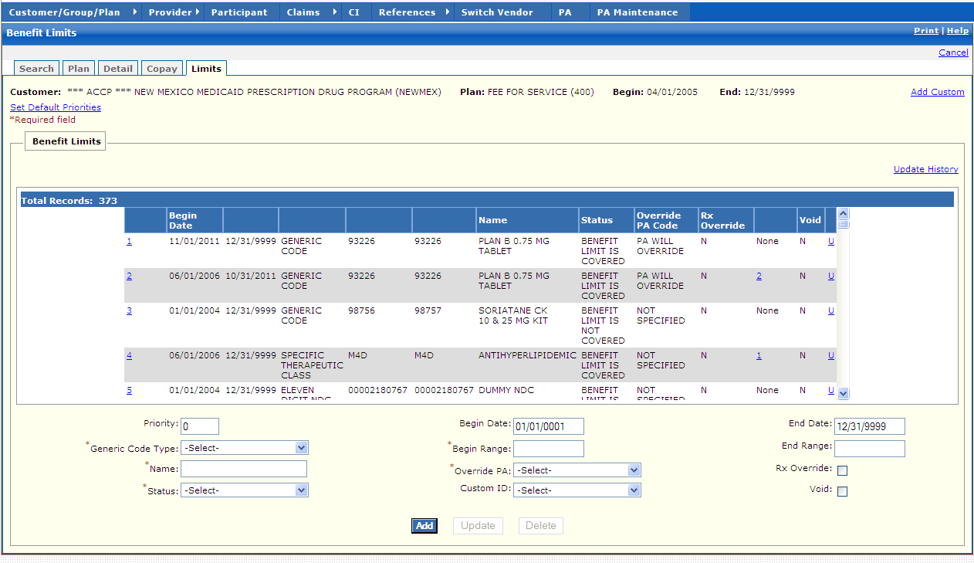

New Mexico PDCS OS PLUS Customer/Group/Plan Subsystem
Window Exhibit
Plan Functional Group
Limits Tab Page
Field Name | Table Column Name | Table Name | Format | Prot. (A,C,N) | Req.  (A,C,N) | Std. Edits | Specifications | Note  Ref.
Customer | R_CUST_NAM & | R_CUST_DTL_TB | Display | A | N | N/A | This field is populated based on the Customer ID chosen upon login.
Plan | R_PLAN_NAM & R_PLAN_ID | R_PLAN_DTL_TB | Display | A | N | N/A | These fields are populated based on the Plan ID chosen in the Plan subsystem
Begin | R_PLAN_BEG_DT | R_PLAN_DTL_TB | Display | A | N | N/A | This field is populated based on the Plan ID chosen in the Plan subsystem
End | R_PLAN_END_DT | R_PLAN_DTL_TB | Display | A | N | N/A | This field is populated based on the Plan ID chosen in the Plan subsystem
Add Custom | N/A | N/A | Link | N | N | N/A | By clicking this link, the user lands on the Add Custom page; where the Custom information can be added to the system
Set Default Priorities | N/A | N/A | Link | N | N | N/A
Benefit Limits Display | Group | N/A | Free Form | N/A | N/A | N/A | Grouping
Priority | R_TYP_PRIORITY_NUM | R_PLN_BENE_LMT_TB | 9,999 | A | N | N/A
Begin Date | R_PBL_BEG_DT | R_PLN_BENE_LMT_TB | DATE | A | N | N/A
End Date | R_PBL_END_DT | R_PLN_BENE_LMT_TB | DATE | A | N | N/A
Type | R_PBL_TYP_CD | R_PLN_BENE_LMT_TB | X (1) | A | N | N/A
Begin Range | R_PBL_RNGE_BEG_CD | R_PLN_BENE_LMT_TB | X (11) | A | N | N/A
End Range | R_PBL_RNGE_END_CD | R_PLN_BENE_LMT_TB | X (11) | A | N | N/A
Name | R_PBL_RNGE_NAM | R_PLN_BENE_LMT_TB | X (60) | A | N | N/A
Status | R_PBL_LMT_STAT_CD | R_PLN_BENE_LMT_TB | X (1) | A | N | N/A
Override PA Code | R_PBL_OVRRD_PA_CD | R_PLN_BENE_LMT_TB | X (1) | A | N | N/A
Rx Override | R_PBL_MED_CERT_IND | R_PLN_BENE_LMT_TB | X (1) | A | N | N/A
Custom ID | R_CUSTOM_ID | R_PLN_BENE_LMT_TB | 999999999 | A | N | N/A
Void | R_VOID_IND | R_PLN_BENE_LMT_TB | X (1) | A | N | N/A
Total Records | N/A | N/A | Display | A | N | N/A | Computed
Benefit Limits Entry | Group | N/A | Free Form | N/A | N/A | N/A | Grouping
Priority | R_TYP_PRIORITY_NUM | R_PLN_BENE_LMT_TB | 9,999 | N | N | N | Default to 0 | R1
Generic Code Type | R_PBL_TYP_CD | R_PLN_BENE_LMT_TB | Drop-down | N | A | V | Valid Values List 8471
Name | R_PBL_RNGE_NAM | R_PLN_BENE_LMT_TB | X (60) | N | A | N/A |  | R3
Status | R_PBL_LMT_STAT_CD | R_PLN_BENE_LMT_TB | Drop-down | N | A | V | Valid Values List 1383
Begin Date | R_PBL_BEG_DT | R_PLN_BENE_LMT_TB | DATE | A | C | D | This field is always required if any other data is entered on the row.  Format is MM/DD/CCYY .Must be a valid date.  Default to current date .
Begin Range | R_PBL_RNGE_BEG_CD | R_PLN_BENE_LMT_TB | X (11) | N | N | N/A | Begin Ranges data must reflect type chosen in Generic Code Type Field. | R2
Override PA | R_PBL_OVRRD_PA_CD | R_PLN_BENE_LMT_TB | Drop-down | N | A | V | Valid Values List 4451
Custom ID | R_CUSTOM_ID | R_PLN_BENE_LMT_TB | Drop-down | N | N | N/A
End Date | R_PBL_END_DT | R_PLN_BENE_LMT_TB | DATE | A | C | D | This field is always required if any other data is entered on the row.  Format is MM/DD/CCYY .Must be a valid date .
End Range | R_PBL_RNGE_END_CD | R_PLN_BENE_LMT_TB | X (11) | N | N | N/A | Begin Ranges data must reflect type chosen in Generic Code Type Field. | R2
Rx Override | R_PBL_MED_CERT_IND | R_PLN_BENE_LMT_TB | Drop-down | N | N | V | Valid Values List 2775 | R4
Void | R_VOID_IND | R_PLN_BENE_LMT_TB | Check Box | N | N | N/A |  | R5
Command Buttons | Group | N/A | Button Row | N/A | N/A | N/A
Add | N/A | N/A | Push Button | N | N | N/A | When selected, a new Benefit Limit that has been entered is added.
Update | N/A | N/A | Push Button | N | N | N/A | When selected, a current Benefit Limit row is updated with any changes entered in the selected Benefit Limit record.
Delete | N/A | N/A | Push Button | N | N | N/A | When selected, the current Benefit Limit record is deleted.

Legend
Prot. and Req. | Standard Edits | Note Ref.
A = Always | D = Date Edit | C = Customer-specific field or functionality
C = Conditionally | N = Numeric Edits | R = Note Reference
N = Never | S = System Generated
 | V = Valid Value Edit

Ref. No. | Notes
R1 | Adjudication uses Priority Number to read the Plan Limits .Once a drug falls into one of the rules, it stops looking at the Plan Limits and move to the next step in the program .If the claim is compound claim, the Plan Limits is read for each drug entered on the claim.
R2 | Range Begin and Range End can represent categories as follows: NCPDP Drug Categories, NCPDP Drug Class, DEA Schedule Code, Eleven Digit NDC, Nine Digit NDC, GCN, GSN, Route of Administration, and Specific Therapeutic Class .For example, there may be a range of GSNs that should not be covered .The Range Begin might be 051784 and the Range End might be 051787 .The rule would include the following GSNs 051784, 051784, 051785, 051786, and 051787.
R3 | The Range Name should be a name that easily identifies what type of products this range includes .For example, one row could have a range for a Therapeutic class of B3K with a Name of Cough and Cold as Not Covered and another row could have range of 19031-19032 with Anevive as Covered .The Range Name allows quicker identification of coverage and can be defined by customer.
R4 | When the Rx Override Box is checked, the Rx Override can be used to change the outcome of the disposition of a claim .If the RxOverride Check Box is not checked, the Rx Override functionality cannot be used to change the outcome of the disposition of a claim.
R5 | When the Void box is checked on a Plan Benefit Limit row, that row is ignored during adjudication.

New Mexico PDCS OS PLUS Customer/Group/Plan Subsystem
Window Specification
Plan Functional Group
Custom Record Detail

Window Name:
Plan: Custom Record Detail
Description:
This window is used to update or view custom records associated with specific benefit coverage from the plan benefit limit window .The PDCS OS PLUS system allows multiple iterations of Custom data with different effective dates within one plan benefit limit .Also, a given instance of custom data can be assigned to one or more plan benefit limits entries within the customer and plan.

Custom records can be set up for covered drugs .A custom record further restricts coverage for certain drugs .When a claim is processed, edits are performed to determine if the days supply or units are entered on the custom record .Edits can be set to deny for duration of time that includes a specified duration of days, months or years of history, or, the number of units allowed during a particular time frame (days, months, or years).

Copay limits can be set on custom records to override the default copayment set on the plan or to provide for additional copayment amounts on defined drugs .In addition, the custom window also has maximum and minimum age edits, gender edits, minimum and maximum daily dose edits, maintenance dose edits, and maximum number of refill edits .Edit exemption indicators can be set to process against current claims to deny .This can be used to set up denials for script limits, refill too soon, duplicate check and maintenance drug edits, or to override the limits in place on the plan header or detail.

The Benefit Limits Custom window is accessed from the Benefit Limits window by clicking the “Custom ID” link on an existing benefit limit record or by clicking the “Add Custom” link in the top right corner .The Custom Record Detail window consists of identifying record information, changeable parameters, and a table in the top right corner showing the custom records available for the current Plan ID .The detail area to the left and below the table shows all the fields contained in one custom row in the custom table .When the Custom Record Detail window is first entered, the detail does not contain any data in the fields .A new Custom row can be created by entering data into the data fields and clicking Save .An existing Custom row of data can be selected for viewing by clicking a Custom ID in the table .Once selected, an existing Custom row of data can be viewed and optionally assigned to the Benefit Limits record being worked.
Window Type:
Response window
Navigation:
The user enters this window by clicking on the Plan tab and then the Limits tab while in the Plan subsystem.
Interface to Other Subsystem(s):
N/A
Interface to Other Application(s):
N/A
Special Security Requirements:
Duplicate functionality for plan information is restricted to authorized users.
Presentation Sequence(s):
N/A
Remarks:
N/A

New Mexico PDCS OS PLUS Customer/Group/Plan Subsystem
Window Layout
Plan Functional Group
Custom Record Detail

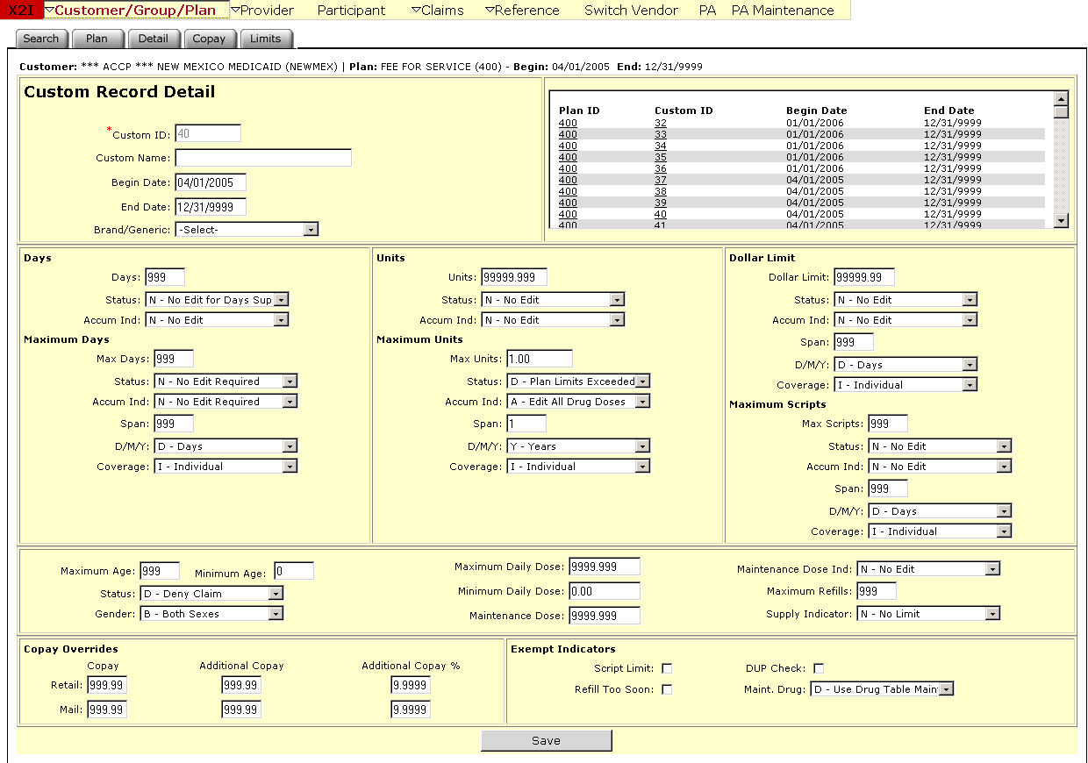

New Mexico PDCS OS PLUS Customer/Group/Plan Subsystem
Window Exhibit
Plan Functional Group
Custom Record Detail
Field Name | Table Column Name | Table Name | Format | Prot. (A,C,N) | Req.  (A,C,N) | Std. Edits | Specifications | Note  Ref.
Customer | R_CUST_NAM & R_CUST_ID | R_CUST_DTL_TB | Display | A | N | N/A | This field is populated based on the Customer ID chosen upon login.
Plan | R_PLAN_NAM & R_PLAN_ID | R_PLAN_DTL_TB | Display | A | N | N/A | These fields are populated based on the Plan ID chosen in the Plan subsystem
Begin | R_PLAN_BEG_DT | R_PLAN_DTL_TB | Display | A | N | N/A | This field is populated based on the Plan ID chosen in the Plan subsystem
End | R_PLAN_END_DT | R_PLAN_DTL_TB | Display | A | N | N/A | This field is populated based on the Plan ID chosen in the Plan subsystem
Custom Record Detail Display | Group | N/A | Free Form | N/A | N/A | N/A | Grouping
Plan ID | R_PLAN_ID | R_PLN_BENE_CSTM_TB | X (3) | A | N | N/A
Custom ID | R_CUSTOM_ID | R_PLN_BENE_CSTM_TB | 999,999,99,9 | A | N | N/A
Begin Date | R_PBL_BEG_DT | R_PLN_BENE_CSTM_TB | DATE | A | N | N/A
End Date | R_PBL_END_DT | R_PLN_BENE_CSTM_TB | DATE | A | N | N/A
Custom Record Detail Entry | Group | N/A | Free Form | N/A | N/A | N/A | Grouping
Custom ID | R_CUSTOM_ID | R_PLN_BENE_CSTM_TB | 999,999,99,9 | N | A | N | Custom ID cannot be zero .Required field.
Custom Name | R_CUSTOM_NAM | R_PLN_BENE_CSTM_TB | X (50) | N | N | N/A
Begin Date | R_PBL_BEG_DT | R_PLN_BENE_CSTM_TB | DATE | A | C | D | This field is always required if any other data is entered on the row.  Format is MM/DD/CCYY .Must be a valid date .
End Date | R_PBL_END_DT | R_PLN_BENE_CSTM_TB | DATE | A | C | D | This field is always required if any other data is entered on the row.  Format is MM/DD/CCYY .Must be a valid date .
Brand/Generic | R_BRND_GNRIC_CD | R_PLN_BENE_CSTM_TB | Drop-down | N | N | V | Valid Values List 5294
Days | Group | N/A | Free Form | N/A | N/A | N/A | Grouping
Days | R_PBL_DAY_SUBM_  NUM | R_PLN_BENE_CSTM_TB | 9,999 | N | N | N | Default to 999
Status | R_PBL_DAYS_STAT_CD | R_PLN_BENE_CSTM_TB | Drop-down | N | N | V | Default to N-Not edit for Days Supply  Valid Values List 194
Accum Ind | R_PBL_DAYS_ACUM_  CD | R_PLN_BENE_CSTM_TB | Drop-down | N | N | V | Default to N- No Edit  Valid Values List 9921
Maximum Days | Group | N/A | Free Form | N/A | N/A | N/A | Grouping | Days
Max Days | R_DAYS_SPLY_NUM | R_PLN_BENE_CSTM_TB | 9,999 | N | N | N | Default to 999
Status | R_DAY_SPLY_STAT_CD | R_PLN_BENE_CSTM_TB | Drop-down | N | N | V | Default to N-No Edit Required  Valid Values List 6784
Accum Ind | R_DAY_SPLY_ACUM_  CD | R_PLN_BENE_CSTM_TB | Drop-down | N | N | V | Default to N-No Edit Required  Valid Values List 3161
Span | R_DAY_SPLY_SPN_  NUM | R_PLN_BENE_CSTM_TB | 9,999 | N | N | N | Default to 999
D/M/Y | R_DAY_SPLY_SPN_CD | R_PLN_BENE_CSTM_TB | Drop-down | N | N | V | Default to D-Days  Valid Values List 8741
Coverage | R_DAY_SPLY_CVRG  _CD | R_PLN_BENE_CSTM_TB | Drop-down | N | N | V | Default to I-Individual  Valid Values List 7335
Units | Group | N/A | Free Form | N/A | N/A | N/A | Grouping
Units | R_UNITS_LMT_NUM | R_PLN_BENE_CSTM_TB | 999,999.999 | N | N | N | Default to 9999.999
Status | R_UNITS_STAT_CD | R_PLN_BENE_CSTM_TB | Drop-down | N | N | V | Default to N-No Edit  Valid Values List 5123
Accum Ind | R_MAX_UNIT_ACUM_CD | R_PLN_BENE_CSTM_TB | Drop-down | N | N | V | Default to N-No-Edit  Valid Values List 4061
Maximum Units | Group | N/A | Free Form | N/A | N/A | N/A | Grouping
Max Units | R_DUR_UNIT_LMT_NUM | R_PLN_BENE_CSTM_TB | 999,999.999 | N | N | N | Default to 9999.999
Status | R_DUR_UNIT_STAT_CD | R_PLN_BENE_CSTM_TB | Drop-down | N | N | V | Default to N-No Edit  Valid Values List 9075
Accum Ind | R_DUR_UNIT_ACUM_CD | R_PLN_BENE_CSTM_TB | Drop-down | N | N | V | Default to N-No Edit  Valid Values List 1066
Span | R_DUR_SPAN_NUM | R_PLN_BENE_CSTM_TB | 9,999 | N | N | N | Default to 999
D/M/Y | R_DUR_UNIT_SPAN_CD | R_PLN_BENE_CSTM_TB | Drop-down | N | N | V | Default to D-Days  Valid Values List 7537
Coverage | R_DUR_CVRG_CD | R_PLN_BENE_CSTM_TB | Drop-down | N | N | V | Default to I-Individual  Valid Values List 8122
Dollar Limit | Group | N/A | Free Form | N/A | N/A | N/A | Grouping
Dollar Limit | R_PBL_AMT_LMT | R_PLN_BENE_CSTM_TB | 999,999,999.99 | N | N | N | Default to 99999.99
Status | R_AMT_LMT_STAT_CD | R_PLN_BENE_CSTM_TB | Drop-down | N | N | V | Default to N-No Edit  Valid Values List 5902
Accum Ind | R_AMT_LMT_ACUM  _CD | R_PLN_BENE_CSTM_TB | Drop-down | N | N | V | Default to N-No-Edit  Valid Values List 4971
Span | R_AMT_LMT_SPN_NUM | R_PLN_BENE_CSTM_TB | 9,999 | N | N | N | Default to 999
D/M/Y | R_AMT_LMT_SPN_CD | R_PLN_BENE_CSTM_TB | Drop-down | N | N | V | Default to D-Days  Valid Values List 95
Coverage | R_AMT_LMT_CVRG_CD | R_PLN_BENE_CSTM_TB | Drop-down | N | N | V | Default to I-Individual  Valid Values List 7361
Maximum Scripts | Group | N/A | Free Form | N/A | N/A | N/A | Grouping | Days
Max Scripts | R_PBL_MAX_RX_NUM | R_PLN_BENE_CSTM_TB | 9,999 | N | N | N | Default to 999
Status | R_MAX_RX_STAT_CD | R_PLN_BENE_CSTM_TB | Drop-down | N | N | V | Default to N-No Edit  Valid Values List 6616
Accum Ind | R_MAX_RX_ACUM_CD | R_PLN_BENE_CSTM_TB | Drop-down | N | N | V | Default to N-No Edit  Valid Values List 9148
Span | R_MAX_RX_SPN_NUM | R_PLN_BENE_CSTM_TB | 9,999 | N | N | N | Default to 999
D/M/Y | R_MAX_RX_SPN_CD | R_PLN_BENE_CSTM_TB | Drop-down | N | N | V | Default to D-Days  Valid Values List 9631
Coverage | R_MAX_RX_CVRG_CD | R_PLN_BENE_CSTM_TB | Drop-down | N | N | V | Default to I-Individual  Valid Values List 2722
Other Indicators  (not labeled) | Group | N/A | Free Form | N/A | N/A | N/A | Grouping | Days
Maximum Age | R_PBL_MAX_AGE | R_PLN_BENE_CSTM_TB | 9,999 | N | N | N | Default to 999
Minimum Age | R_PBL_MIN_AGE | R_PLN_BENE_CSTM_TB | 9,999 | N | N | N | Default to 999
Status | R_PBL_AGE_STAT_CD | R_PLN_BENE_CSTM_TB | Drop-down | N | N | V | Default to N-No Edit  Valid Values List 764
Gender | R_PBL_SEX_CD | R_PLN_BENE_CSTM_TB | Drop-down | N | N | V | Default to B-Both Sexes  Valid Values List 2604
Maximum Daily Dose | R_PBL_MAX_DOSE_  NUM | R_PLN_BENE_CSTM_TB | 999,999.999 | N | N | N | Default to 9999.999
Minimum Daily Dose | R_PBL_MIN_DOSE_  NUM | R_PLN_BENE_CSTM_TB | 999,999.999 | N | N | N | Default to 9999.999
Maintenance Dose | R_MAINT_DOSE_NUM | R_PLN_BENE_CSTM_TB | 999,999.999 | N | N | N | Default to 9999.999
Maintenance Dose Ind | R_MAINT_DOSE_CD | R_PLN_BENE_CSTM_TB | Drop-down | N | N | V | Default to N-No Edit  Valid Values List 4517
Maximum Refills | R_MAX_REFLL_NUM | R_PLN_BENE_CSTM_TB | 9,999 | N | N | N | Default to 999
Supply Indicator | R_PBL_SUPPLY_CD | R_PLN_BENE_CSTM_TB | Drop-down | N | N | V | Default to N-No Limit  Valid Values List 8074
Copay Overrides | Group | N/A | Free Form | N/A | N/A | N/A | Grouping
Copay (Retail) | R_COPAY_RTL_AMT | R_PLN_BENE_CSTM_TB | 9,999,999.99 | N | N | N | Default to 999.99
Copay (Mail Order) | R_MAIL_ORD_AMT | R_PLN_BENE_CSTM_TB | 9,999,999.99 | N | N | N | Default to 999.99
Additional Copay (Retail) | R_ADDL_RTL_AMT | R_PLN_BENE_CSTM_TB | 9,999,999.99 | N | N | N | Default to 999.99
Additional Copay (Mail Order) | R_ADDL_MAIL_AMT | R_PLN_BENE_CSTM_TB | 9,999,999.99 | N | N | N | Default to 999.99
Additional Copay % (Retail) | R_ADDL_RTL_PCT | R_PLN_BENE_CSTM_TB | 9.9999 | N | N | N | Default to 9.9999
Additional Copay % (Mail Order) | R_ADDL_MAIL_PCT | R_PLN_BENE_CSTM_TB | 9.9999 | N | N | N | Default to 9.9999
Exempt Indicators | Group | N/A | Free Form | N/A | N/A | N/A | Grouping | Days
Script Limit | R_RX_LMT_EXMT_IND | R_PLN_BENE_CSTM_TB | Check Box | N | N | N | Default to blank
Refill Too Soon | R_REFLL_EXMT_IND | R_PLN_BENE_CSTM_TB | Check Box | N | N | N | Default to blank
DUP check | R_DUPCK_EXMT_IND | R_PLN_BENE_CSTM_TB | Check Box | N | N | N | Default to blank
Maint. Drug | R_MAINT_DRUG_CD | R_PLN_BENE_CSTM_TB | Drop-down | N | N | V | Default to D-Use Drug Table Maintenance  Valid Values List 6656
Command Button | Group | N/A | Button Row | N/A | N/A | N/A | Grouping
Save | N/A | N/A | Push Button | N | N | N/A | Upon Saving, any additional validation is completed .Once all data passes validation, the record is saved.

Legend
Prot. and Req. | Standard Edits | Note Ref.
A = Always | D = Date Edit | C = Customer-specific field or functionality
C = Conditionally | N = Numeric Edits | R = Note Reference
N = Never | S = System Generated
 | V = Valid Value Edit

Ref. No. | Notes
N/A | N/A

